

Curriculum Progression Map
St Mary and St Joseph’s RC Primary School
Design and Technology Progression Grid – Year Three
Singing | Listening
• Sing a widening range of unison songs of varying styles and structures, tunefully and with expression.  • Perform actions and body percussion confidently and in time to a range of action songs  • Experience singing canons, simple rounds and other partner songs.  • Show control of dynamics and tempo when singing and playing, following physical and written symbols:  dynamics – p f (loud/soft); tempo – allegro, adagio (fast/slow) | • Listen with increasing concentration and recognise how the inter-related dimensions of music can be used to create different moods and effects.  • Appreciate and understand a growing range of live and recorded music drawn from different traditions and historical periods and from great composers and musicians.  • Recognise the different instrumental families when watching musical performances and begin to recognise the sounds they make
Composing |  | Musicianship and performing
.• Improvise (using voices and tuned/untuned instruments), inventing short ‘on-the-spot’ responses and using a given note-range (where appropriate).  • Compose in response to different stimuli, e.g. stories, images and musical sources, thoughtfully using the inter-related dimensions of music to create specific effects and atmospheres, and record using standard and graphic notation.  • Structure musical ideas to create music that has a beginning, middle and end.  • Begin to compose simple rhythmic patterns and song accompaniments on untuned percussion using  crotchets (walk), paired quavers (jogging), minims (stride) and crotchet rests.  • Combine known rhythmic notation with letter names to create rising and falling phrases using just three notes (do, re and mi).  • Explore and develop using Music Technology (where available) to capture, change and combine sounds. |  | Pulse &Rhythm  • Find and maintain the pulse of a piece of music using body percussion and instruments, responding to changes in tempo (speed.)  • Understand the difference between pulse and rhythm.  • Apply word chants to rhythms, understanding how to link each syllable to one musical note  • Identify patterns of one and two sounds per beat plus rests (i.e. crotchets/paired quavers/rests) and use rhythm names (walk/jogging/rest.)  • Play simple ostinato parts (repeating rhythms) on percussion instruments to accompany music and songs.  Pitch  • Play simple melodic patterns using a small number of notes, following staff / dot notation (e.g. C-E/do-mi).  • Use listening skills to correctly order phrases using dot notation, showing different arrangements of notes e.g. C-E/do-mi).  Reading Notation  • Recognise the symbols for crotchets, quavers and crotchet rests.  • Read and clap/tap a 4 beat pattern (e.g. from a flashcard) that contains crotchets, quavers and crotchet rests.  • Introduce the stave, lines and spaces, and clef. Use dot notation to show higher or lower pitch.  Performing  • Rehearse and perform with others, beginning to show an awareness of the audience.
Vocabulary
Timbre – The type of sound – whisper/hum/sing (voice examples) or twinkly/hard/soft (examples with instruments).
Texture – Layers of sound (number of instruments or voices playing together).
Structure – The way the music is laid out – e.g. verse, chorus, verse
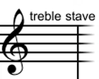
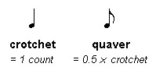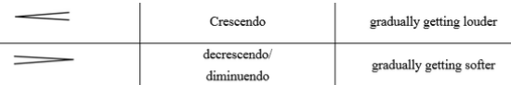
Crotchet rests – 1 count rest

Notation - used to visually represent aurally perceived music played with instruments or sung by the human voice through the use of written, printed, or otherwise-produced symbols.

This list of repertoire is intended to give teachers a good start in terms of choosing music
for Year 3 and to highlight music which is age-appropriate. It should not limit the
imagination and creativity of the teacher in terms of seeking and using other musical
examples.
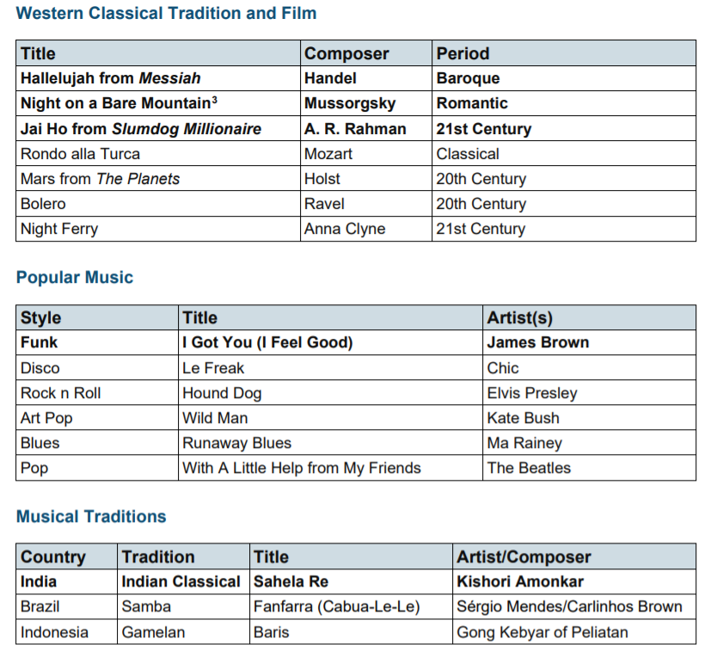
Good repertoire for this age group includes:
• Sing Up: Heads and Shoulders
• Singing Sherlock 2: Si, Si, Si
• Flying a Round: To stop the train
• Trad. Japan: Kaeru no uta
• Trad. Morocco: A ram sam sam/Pease Pudding Hot
• Trad. Bangladesh: Now charia de (A Boatman’s Song)
• Junior Songscape: Listen to the Rain
• Voicelinks: Extreme Weather
• Sing Up: Skye Boat Song
• Trad. Ireland: Be Thou My Vision
• Junior Voiceworks 1: Now The Sun Is Shining
• Voiceworks 1: Candle Light
• Singing Sherlock 2: Shadow
• Singing Express 3: Mirror
• Trad. England: Ah! Poor bird/Hey, Ho! Nobody home/Rose



