



School Prayer This Week
Dear God, thank you for the love and happiness you bring into our lives. Help is to be caring, thoughtful and thankful. Please guide us to make good choices and to appreciate what really matters. Amen.

St Mary & St Joseph’s Newsletter 18th Sept 2026
20

School Information

- Medication at school – As we begin the new term, we kindly remind parents to bring or return any medication your child needs into school. You will also need to fill out a medicine form from the office and provide any updated care plans from medical professions. If you child has Asthma, please can you come into school and fill out a school asthma card.

- School Uniform - Please can all children wear their full uniform and make sure they are wearing school shoes NOT trainers unless it is PE. Ties & Book Bags can be bought from the school office or via school gateway; Ties are £4.50. Book bags are £3.50. PE tops and long-sleeved quarter zips can also be purchased via our online supplier here.

- Breakfast Club – Our breakfast club is open from 7.45am each morning and costs only £1 each day. Children will also receive breakfast and a drink. Children can attend any morning and will just need to bring a £1 per day.

Urgent Reminder
This is a reminder that we are a Nut free school. We have had a few children bring nuts or Nutella into school. We have both children and staff with severe nut allergies that they could become very poorly. Thank you for your understanding.

School Attendance and Punctuality
Reception | 92.1% | Year 1 | 100% | Year 2 | 97.1%
Year 3 | 95.8% | Year 4 | 97.8% | Year 5 | 98.8%
 | Year 6 | 97.5% | Overall total | 97.0%

This week’s winners – Attendance – Year 1, Punctuality – Year 1


Year 1 achieved 100% attendance and punctuality this week, amazing effort!


Diary

Friday 25th Sept | Non-uniform day £1 – Christmas Fayre
Thurs 16th Oct | Non-uniform for Foodbank – food donation
Wed 21st Oct | Break up for half term at 3.25pm
Mon 2nd Nov | School re-opens at 8:45am

St Mary & St Joseph’s Newsletter 18th Sept 2026
20

Secondary school and Primary school admissions
Please see below the key dates and deadlines for admissions, there is a QR code.



Scheduled PE Days for Classes

Tuesday – Reception, Year 3 & Year 4
Wednesday – Year 2 & Year 6
Thursday – Reception, Year 1 & Year 5

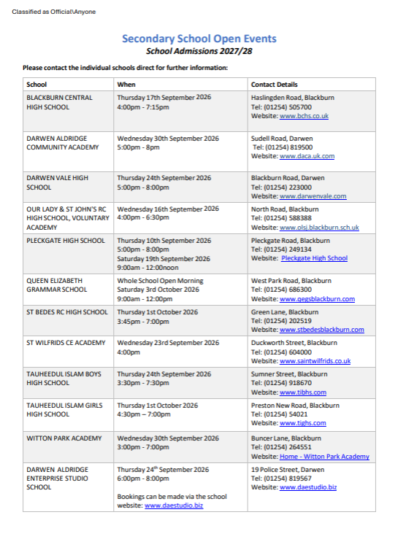

St Mary & St Joseph’s Newsletter 18th Sept 2026
20

St Mary & St Joseph’s Newsletter 18th Sept 2026
20



St Mary & St Joseph’s Newsletter 18th Sept 2026
20



