



School Prayer This Week
Dear God, thank you for digital technology and the ways it helps us to learn, discover and have fun. Help us to keep a healthy balance by remembering to put our devices down so we can enjoy playing outside, being creative and spending time with the people we love. Amen.
St Mary & St Joseph’s Newsletter 11th Sept 2026
20

Welcome back everyone

- Medication at school – As we begin the new term, we kindly remind parents to bring or return any medication your child needs into school. You will also need to fill out a medicine form from the office and provide any updated care plans from medical professions. If you child has Asthma, please can you come into school and fill out a school asthma card.

- School Uniform - Please can all children wear their full uniform and make sure they are wearing school shoes NOT trainers unless it is PE. Ties & Book Bags can be bought from the school office or via school gateway; Ties are £4.50. Book bags are £3.50. PE tops and long-sleeved quarter zips can also be purchased via our online supplier here.

- Breakfast Club – Our breakfast club is open from 7.45am each morning and costs only £1 each day. Children will also receive breakfast and a drink. Children can attend any morning and will just need to bring a £1 per day.

Urgent Reminder
This is a reminder that we are a Nut free school. We have had a few children bring nuts or Nutella into school. We have both children and staff with severe nut allergies that they could become very poorly. Thank you for your understanding.

School Attendance and Punctuality
Reception | 97.0% | Year 1 | 96.3% | Year 2 | 98.0%
Year 3 | 93.7% | Year 4 | 97.9% | Year 5 | 98.7%
 | Year 6 | 98.7% | Overall total | 98.7%

This week’s winners – Attendance - Year 5 , Punctuality – Year 4 + Year 6

Diary

Tues 15th Sep | Mass at 11am
Fri 25th Sep | Non- uniform day for £1 donation to school
Wed 21st Oct | Break up for half term at 3.25pm

St Mary & St Joseph’s Newsletter 11th Sept 2026
20

Scheduled PE Days for Classes

Tuesday – Reception, Year 3 & Year 4
Wednesday – Year 2 & Year 6
Thursday – Reception, Year 1 & Year 5

High school and Primary school admissions
Please see below the key dates and deadlines for admissions, there is a QR code.


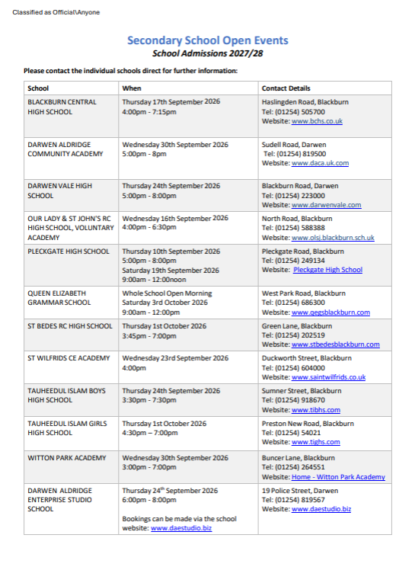

St Mary & St Joseph’s Newsletter 11th Sept 2026
20

St Mary & St Joseph’s Newsletter 11th Sept 2026
20



St Mary & St Joseph’s Newsletter 11th Sept 2026
20



