



School Prayer This Week
Dear God, thank you for digital technology and the ways it helps us to learn, discover and have fun. Help us to keep a healthy balance by remembering to put our devices down so we can enjoy playing outside, being creative and spending time with the people we love. Amen.
St Mary & St Joseph’s Newsletter 4th Sept 2026
20

Welcome back everyone

- Welcome back! It's absolutely wonderful to see everyone again, and wow—what fantastic attendance this week! You're all doing an amazing job keeping the momentum going.
We've also had the joy of welcoming our new reception class this week! It's such a special time watching our youngest learners settle in and explore their new classroom. Here's to a fantastic year ahead!

- School Uniform - Please can all children wear their full uniform and make sure they are wearing school shoes NOT trainers unless it is PE. Ties & Book Bags can be bought from the school office or via school gateway; Ties are £4.50. Book bags are £3.50. PE tops and long-sleeved quarter zips can also be purchased via our online supplier here.

- Breakfast Club – Our breakfast club is open from 7.45am each morning and costs only £1 each day. Children will also receive breakfast and a drink. Children can attend any morning and will just need to bring a £1 per day.

Urgent Reminder
This is a reminder that we are a Nut free school. We have had a few children bring nuts or Nutella into school. We have both children and staff with severe nut allergies that they could become very poorly. Thank you for your understanding.

School Attendance and Punctuality
We are introducing a new software to track our school’s attendance called ‘Attend’. You will receive regular updates regarding your child’s attendance and punctuality along with congratulatory emails for good or improved attendance. Please look out for these during this year.

Diary

Fri 11th Sep | Non-uniform day for £1 donation to school
Tues 15th Sep | Mass at 11am
Fri 25th Sep | Non- uniform day for £1 donation to school
Wed 21st Oct | Break up for half term at 3.25pm

Guidance regarding wearing earrings at school

Please see snapshot below for guidance regarding wearing earrings for physical activity at school. As we have active playtimes throughout the day, we would request that children no longer wear earrings for school on any day, thank you.
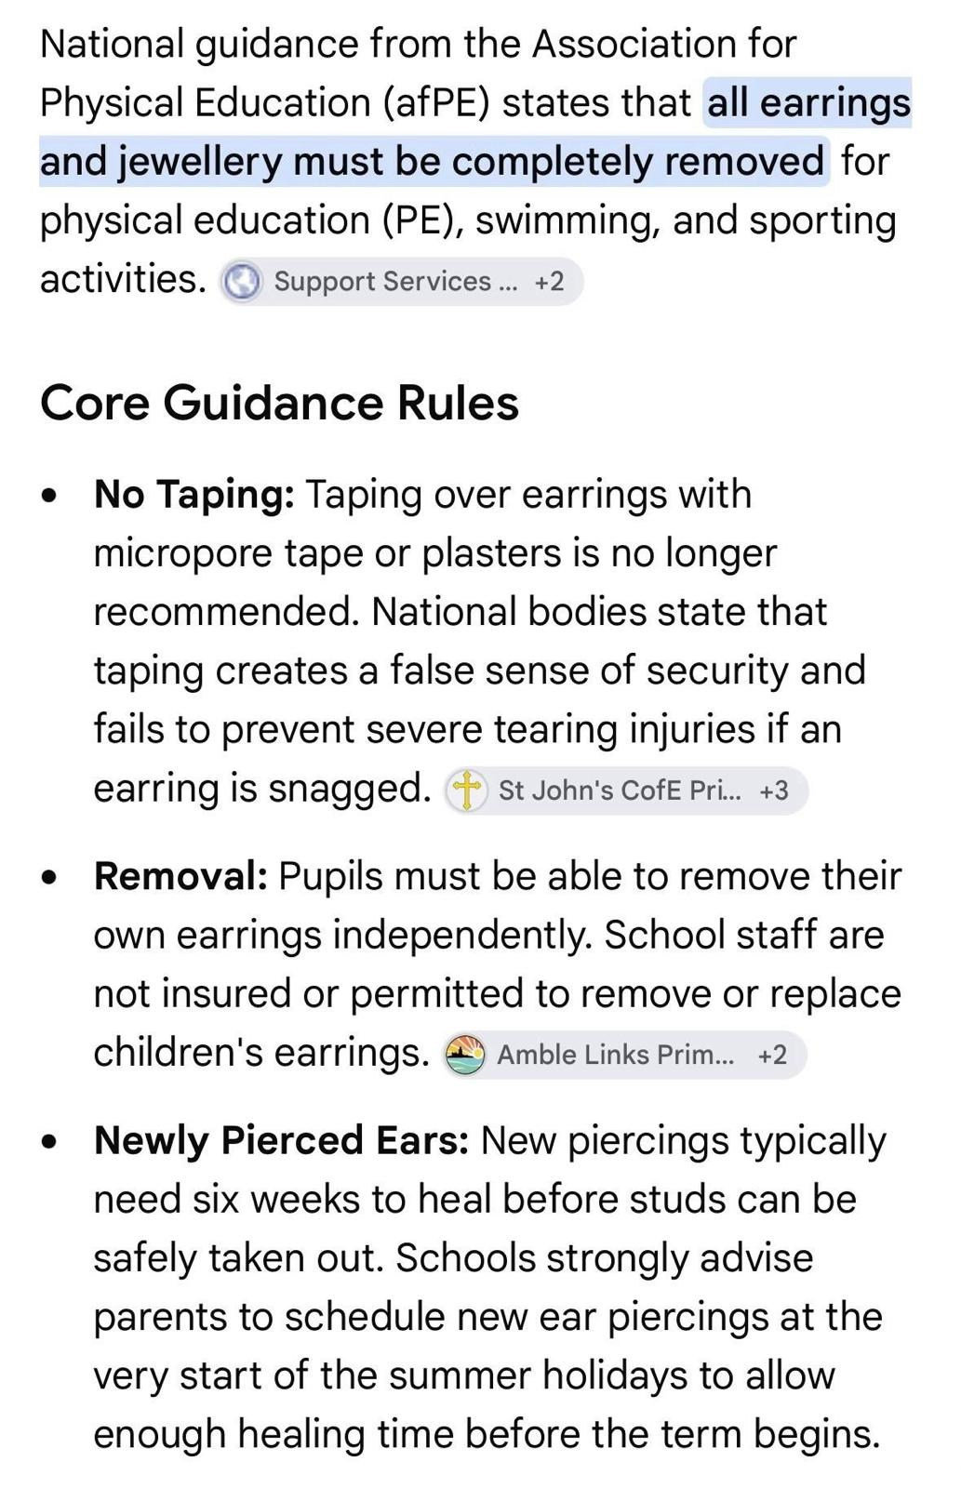
St Mary & St Joseph’s Newsletter 4th Sept 2026
20


Scheduled PE Days for Classes

Tuesday – Reception, Year 3 & Year 4
Wednesday – Year 2 & Year 6
Thursday – Reception, Year 1 & Year 5

St Mary & St Joseph’s Newsletter 4th Sept 2026
20


St Mary & St Joseph’s Newsletter 4th Sept 2026
20

St Mary & St Joseph’s Newsletter 17th July 2026
20

St Mary & St Joseph’s Newsletter 4th Sept 2026
20


