Starts september 2026 | Monday | Tick Option | Tuesday | Tick Option | Wednesday | Tick Option | Thursday | Tick Option | Friday | Tick Option
Week 1  MAIN – choose one option | Margherita Pizza, Criss Cross potato, beans or spaghetti |  | Meat Free Pasta Bolognaise served with Garlic Bread |  | CHICKEN NUGGETS WITH CHIPPED POTATOES AND MIXED VEGETABLES  NON HALAL  HALAL |  | Chicken Tikka MASALA with Savoury Rice  Non Halal  Halal |  | SALMON & COD Fish CAKES with Chipped Potatoes and BEANS OR SPAGHETTI
Week 1  MAIN – choose one option | Jacket potato with a choice of fillings -  Beans  Cheese  Tuna |  | Jacket Potato with a choice of fillings -  Beans  Cheese  Tuna |  | Jacket potato with a choice of fillings -  Beans  Cheese  Tuna |  | Jacket potato with a choice of fillings -  Beans  Cheese  Tuna |  | Poached egg  Served with Chipped Potatoes and Beans | 
Week 1  MAIN – choose one option | wrap with a choice of filling  - Ham  - Cheese  - Tuna  - Egg  Served with Tortilla Chips | Circle your choice of filling | Sandwich with a choice of filling  - Ham  - Cheese  - Tuna  - Egg  Served with Tortilla Chips | Circle your choice of filling | bread roll with a choice of filling  - Ham  - Cheese  - Tuna  - Egg  Served with Tortilla Chips | Circle your choice of filling | Sandwich with a choice of filling  - Ham  - Cheese  - Tuna  - Egg  Served with Tortilla Chips | Circle your choice of filling | wrap with a choice of filling  - Ham  - Cheese  - Tuna  - Egg  Served with Tortilla Chips | Circle your choice of filling
Dessert | Yoghurt  Fresh fruit |  | Yoghurt  Fresh fruit |  | Yoghurt  Fresh fruit |  | Yoghurt  Fresh fruit |  | Yoghurt  Fresh fruit
 | VARIOUS DESSERTS |  | VARIOUS  DESSERTS |  | VARIOUS  DESSERTS |  | VARIOUS DESSERTS |  | VARIOUS  DESSERTS
Also available daily: Salad, bread and fresh fruit with semi-skimmed milk or fresh water.
Starts september 2026 | Monday | Tick Option | Tuesday | Tick Option | Wednesday | Tick Option | Thursday | Tick Option | Friday | Tick Option
Week 2  MAIN – choose one option | pizza whirls with skin on chipped potatoes and beans or spaghetti |  | Meat balls in tomato sauce with mashed potatoes  Non Halal  Halal |  | breakfast brunch  non halal  halal |  | breaded chicken burger in a roll with new potatoes and mixed vegetables  Non Halal  Halal |  | fish fingers with chipped potatoes and beans or spaghetti
Week 2  MAIN – choose one option | Jacket potato with a choice of fillings -  Beans  Cheese  Tuna |  | Jacket potato with a choice of fillings –  Beans  Cheese  Tuna |  | Jacket potato with a choice of fillings –  Beans  Cheese  Tuna |  | Jacket potato with a choice of fillings –  Beans  Cheese  Tuna |  | Poached egg  Served with Chipped Potatoes and Beans
Week 2  MAIN – choose one option | wrap with a choice of filling  - Ham  - Cheese  - Tuna  - Egg  Served with Tortilla Chips | Circle your choice of filling | Sandwich with a choice of filling  - Ham  - Cheese  - Tuna  - Egg  Served with Tortilla Chips | Circle your choice of filling | bread roll with a choice of filling  - Ham  - Cheese  - Tuna  - Egg  Served with Tortilla Chips | Circle your choice of filling | Sandwich with a choice of filling  - Ham  - Cheese  - Tuna  - Egg  Served with Tortilla Chips | Circle your choice of filling | wrap with a choice of filling  - Ham  - Cheese  - Tuna  - Egg  Served with Tortilla Chips | Circle your choice of filling
Dessert | Yoghurt  Fresh fruit |  | Yoghurt  Fresh fruit |  | Yoghurt  Fresh fruit |  | Yoghurt  Fresh fruit |  | Yoghurt  Fresh fruit
 | VARIOUS DESSERTS |  | VARIOUS  DESSERTS |  | VARIOUS  DESSERTS |  | VARIOUS DESSERTS |  | VARIOUS  DESSERTS
Also available daily: Salad, bread and fresh fruit with semi-skimmed milk or fresh water.

starts september 2026 | Monday | Tick Option | Tuesday | Tick Option | Wednesday | Tick Option | Thursday | Tick Option | Friday | Tick Option
Week 3  main – choose one option | cheesy whirls with skin on chipped potatoes and beans or spaghetti |  | creamy chicken pasta served with garlic bread  Non Halal  Halal |  | roasted sausage with roast potatoes, yorkshire pudding and seasonal vegetables  non halal  halal |  | cheese slices with mashed potatoes and peas or beans  Salmon fillet with mashed potatoes and peas or beans |  | Fish goujons with Chipped potatoes and beans or Spaghetti.
Week 3  main – choose one option | Jacket potato with a choice of fillings –  Beans  Cheese  Tuna |  | Jacket potato with a choice of fillings –  Beans  Cheese  Tuna |  | Jacket potato with a choice of fillings –  Beans  Cheese  Tuna |  | Jacket potato with a choice of fillings –  Beans  Cheese  Tuna |  | Poached egg  Served with Chipped Potatoes and Beans
Week 3  main – choose one option | wrap with a choice of filling  - Ham  - Cheese  - Tuna  - Egg  Served with Tortilla Chips | Circle your choice of filling | Sandwich with a choice of filling  - Ham  - Cheese  - Tuna  - Egg  Served with Tortilla Chips | Circle your choice of filling | bread roll with a choice of filling  - Ham  - Cheese  - Tuna  - Egg  Served with Tortilla Chips | Circle your choice of filling | Sandwich with a choice of filling  - Ham  - Cheese  - Tuna  - Egg  Served with Tortilla Chips | Circle your choice of filling | wrap with a choice of filling  - Ham  - Cheese  - Tuna  - Egg  Served with Tortilla Chips | Circle your choice of filling
Dessert | Yoghurt  Fresh fruit |  | Yoghurt  Fresh fruit |  | Yoghurt  Fresh fruit |  | Yoghurt  Fresh fruit |  | Yoghurt  Fresh fruit
 | VARIOUS DESSERTS |  | VARIOUS  DESSERTS |  | VARIOUS  DESSERTS |  | VARIOUS DESSERTS |  | VARIOUS  DESSERTS
Also available daily: Salad, bread and fresh fruit with semi-skimmed milk or fresh water.

Starts September 2026 | Monday | Tick Option | Tuesday | Tick Option | Wednesday | Tick Option | Thursday | Tick Option | Friday | Tick Option
Week 4  main – choose one option | butter pie with seasonal vegetables or beans |  | pizza baguette with crunchy potatoes and beans or spaghetti |  | chicken balti curry with savoury rice  Non Halal  Halal |  | chicken nuggets served with macaroni cheese and dough balls  Non Halal  Halal |  | Fish fingers with chipped potatoes and beans or spaghetti
Week 4  main – choose one option | Jacket potato with a choice of fillings -  Beans  Cheese  Tuna |  | Jacket potato with a choice of fillings –  Beans  Cheese  Tuna |  | Jacket potato with a choice of fillings –  Beans  Cheese  Tuna |  | Jacket potato with a choice of fillings –  Beans  Cheese  Tuna |  | Poached egg  Served with Chipped Potatoes and Beans
Week 4  main – choose one option | wrap with a choice of filling  - Ham  - Cheese  - Tuna  - Egg  Served with Tortilla Chips | Circle your choice of filling | Sandwich with a choice of filling  - Ham  - Cheese  - Tuna  - Egg  Served with Tortilla Chips | Circle your choice of filling | bread roll with a choice of filling  - Ham  - Cheese  - Tuna  - Egg  Served with Tortilla Chips | Circle your choice of filling | Sandwich with a choice of filling  - Ham  - Cheese  - Tuna  - Egg  Served with Tortilla Chips | Circle your choice of filling | wrap with a choice of filling  - Ham  - Cheese  - Tuna  - Egg  Served with Tortilla Chips | Circle your choice of filling
Dessert | Yoghurt  Fresh fruit |  | Yoghurt  Fresh fruit |  | Yoghurt  Fresh fruit |  | Yoghurt  Fresh fruit |  | Yoghurt  Fresh fruit
 | VARIOUS DESSERTS |  | VARIOUS  DESSERTS |  | VARIOUS  DESSERTS |  | VARIOUS DESSERTS |  | VARIOUS  DESSERTS
Also available daily: Salad, bread and fresh fruit with semi-skimmed milk or fresh water.

St Mary and St Joseph’s
Lunch Menu
September 2026
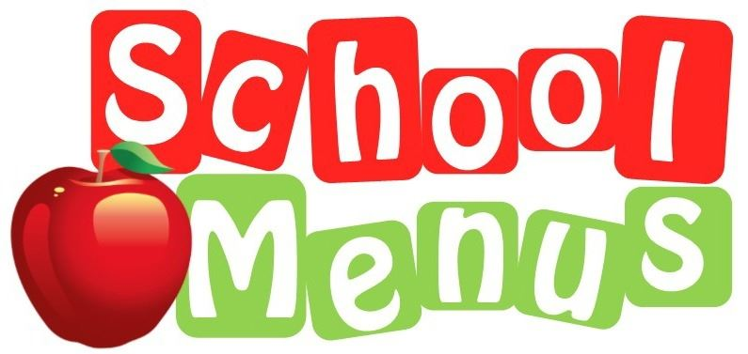

Child’s Name: ______________________ Class: ___________

Allergens - If your child is allergic to one of the 14 main allergens, please ensure you speak to the Main School Office

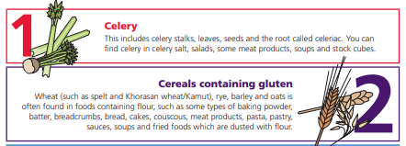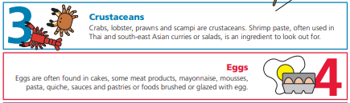
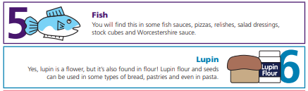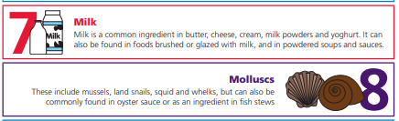
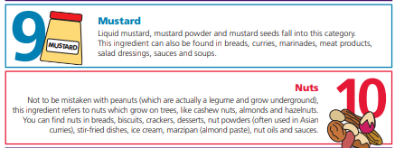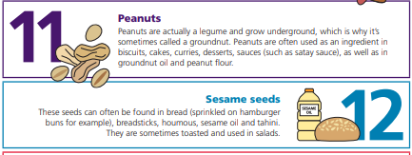

Dietary Requirements
Parents can notify the school office of their child’s dietary requirements, whether religious or medical and these are noted on the system. The Children will wear the appropriate coloured band, all staff members are aware of any dietary requirements to ensure the wrong food item is not given to the child.

S

