Being different, Belonging Together in the family of God
St Mary and St Joseph’s RC Primary School

approved September 2026
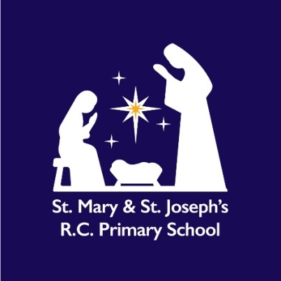
Religious Education Policy
Autumn 2026

Mission Statement
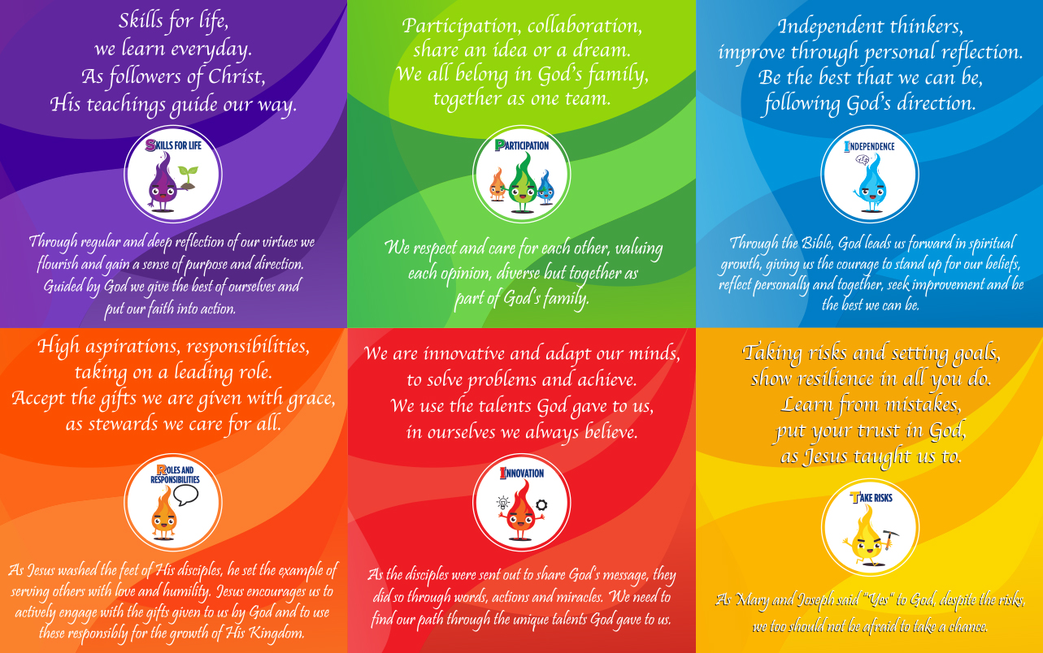

Purpose of and rationale for Religious Education:
Religious Education is a central part of the curriculum in our Catholic school. It is distinctively Catholic in its content and approach, while being genuinely educational in its purpose. RE enables all pupils, regardless of their religious background, to develop knowledge and understanding of the Catholic faith and other religious worldviews. It provides opportunities for pupils to ask questions, think critically, reflect on matters of faith and belief, and consider how these beliefs influence the lives of individuals and communities.
Through Religious Education, pupils are encouraged to develop respect for different beliefs and perspectives, while gaining a secure understanding of the Catholic tradition and the teachings of the Church, in accordance with the requirements of the Diocese of Salford.

Religious Education
The Catholic school is a community of faith in God the Father, God the Son and God the Holy Spirit, and Religious Education is where that faith seeks understanding. The primary aim of Religious Education in a Catholic school is to engage pupils in a comprehensive and systematic study of the mystery of God, the life and teaching of Jesus Christ, the teachings of the Church, the central beliefs of the Catholic faith, the basis for those beliefs, and the relationship between faith and life.
As a Catholic school, our Religious Education curriculum is rooted in the Catholic tradition and reflects the teachings and vision of the Church. It is taught in a way that enables all pupils, whatever their religious background or personal beliefs, to develop knowledge and understanding of the Catholic faith. Pupils are encouraged to ask questions, explore matters of faith and belief, reflect thoughtfully and engage respectfully with different perspectives. Through this, Religious Education contributes both to the religious life of the school and to the academic, personal and spiritual development of every pupil.

The curriculum subject of Religious Education presents the same demand for rigour and for being systematic as any other subject. While for some Religious Education may well deepen and enhance personal faith, and others may discover answers to the deepest questions of life, nevertheless, the primary criteria by which it is judged are educational.

Dialogue and encounter
The Religious Education classroom must be a place of respectful dialogue. Religious Education has an important part to play in this dialogue, by presenting a curriculum that includes a study of other religious traditions and worldviews. There are good reasons why a Catholic Religious Education curriculum must include the study of other religions and worldviews. The first reason is because the Church itself teaches that by virtue of baptism, Catholics are called to engage in dialogue with others. The Church teaches that a shared commitment to the promotion of peaceful societies requires educational institutions to allow various cultural expressions to coexist and, in that context, to promote respectful dialogue. In Catholic schools, where the presence of partners in dialogue occurs naturally due to their diverse nature, Religious Education becomes ideally placed to facilitate this dialogue. The dialogical attitude is nurtured by the Catholic school through its provision of a pluralistic Religious Education curriculum and its modelling of respectful dialogue in classroom practice. The second reason is that it prepares Catholic pupils for the world they will encounter outside of the Catholic atmospheres of the home, parish, and school. In addition, the provision of a pluralistic curriculum that opens for pupils the opportunity to engage in meaningful interreligious and intercultural dialogue gives a rationale for the subject that explains its relevance to all pupils, not just to those who are Catholic. (RED, 2023)

The primacy of Religious Education in the school curriculum
1. Religious Education is the core of the core curriculum and is to be the source and summit of the whole curriculum.
2. Religious Education is an academic discipline with the same systematic demands and rigour as other disciplines. It must be organised, led, coordinated, taught, resourced and quality assured as a core subject.
3. Religious Education is to be delivered within a broad and balanced curriculum, where it informs every aspect of the curriculum. Every other subject is to be informed by Religious Education and have a strong relationship with it.
4. In primary schools there is to be a Religious Education Lead who is to have at least parity in status and remuneration with those of any other curriculum area.
(RED, 2023)

Outcome of Religious Education
The outcome of excellent Religious Education is religiously literate and consciously engaged young people who have the knowledge, understanding, and skills – appropriate to their age and capacity – to reflect spiritually, and think ethically and theologically, and who recognise the demands of religious commitment in everyday life. (RED, 2023)

Compliance with the Religious Education Directory (2023) and Catholic School Inspection

- Catholic schools are required to comply with the Religious Education Directory Primary
schools should ensure full curriculum compliance by September 2026.

- Catholic primary schools in the Diocese of Salford are recommended to teach Religious Education using Lighting the Path scheme as the principal resource from September 2026 in EYFS, Key Stage 1 and Key Stage 2.

- In each year of compulsory schooling, Religious Education is to be taught for at least 10% curriculum time within each repeating cycle of the regular school timetable.

The importance of the Religious Educator
All teachers entrusted with the teaching of Religious Education have a responsibility to deliver the subject with professionalism, sensitivity and respect for the Catholic character of the school. Through their words, relationships and actions, staff contribute to creating a learning environment in which pupils can encounter the teachings of the Catholic faith, explore questions of meaning and purpose, and develop respect for the beliefs of others.

The school recognises and values the commitment of all staff who teach Religious Education, whether Catholic or not. Teachers are expected to support the school's Mission Statement and Catholic ethos, engaging fully with the responsibility of delivering Religious Education in a spirit of dialogue, enquiry and witness. High-quality Religious Education requires good subject knowledge and an ongoing commitment to professional development so that all staff can teach the curriculum with confidence and fidelity.

As Religious Education is the core subject within the Catholic curriculum and is subject to inspection under Section 48, the Religious Education Lead should be a practising Catholic who can provide faith leadership, theological support and professional guidance to colleagues. Working alongside the Headteacher and Diocese, the Religious Education Lead supports staff in delivering the curriculum, developing their subject knowledge and promoting excellence in Religious Education across the school. Through this shared commitment, all staff contribute to the mission of the school and help pupils grow in faith, knowledge, understanding and respect for others.

Curriculum provision: EYFS-KS2
To fulfil the aims of Religious Education and to ensure compliance with the norms set out in the Religious Education Directory (RED, 2023) our curriculum provision for Religious Education follows the model curriculum from the RED and is structured in the following way:

Curriculum branches
The curriculum is structured in six curriculum branches – a branch each half term. The branches are rooted in the story of salvation history and lead pupils/students on a journey each year that gives sequence and progression to their learning. As they revisit each branch in each year of school they come to a deeper understanding of its significance for Catholic belief and practice, as well as other Christian denominations and other religious traditions. The six curriculum branches are:
1. Creation and Covenant,
2. Prophecy and Promise,
3. Galilee to Jerusalem,
4. Desert to Garden,
5. To the ends of the Earth,
6. Dialogue and Encounter.

Knowledge lenses
The first five curriculum branches are divided into four sub-sections called knowledge lenses that set out the object of study for pupils/students. These four sections are:

Hear: focuses on the Word of God which we hear: the Word made flesh, Jesus Christ, a person in whom God is fully revealed, whom we know by faith and who is revealed to us through the Sacred Scriptures and the living tradition of the Church.
Believe: focuses on the content of the Church’s own profession of faith, what she believes, professes, defines, and teaches. In this lens we look at those doctrines that constitute the Catholic faith: trinity, incarnation, the Holy Spirit, the communion of saints, the role of the Blessed Virgin Mary, and salvation and eternal life.
Celebrate: deals with the liturgy in which the Church celebrates the Paschal mystery of Christ which accomplished the work of salvation. In this lens we look at prayer, liturgy, and sacrament, sacraments of initiation, the Eucharist, sacraments of healing, sacraments at the service of communion, and other liturgies and sacramentals.
Live: focuses on the impact of faith on how Christians live. In this lens we look at the dignity of the human person; freedom, conscience, and virtue; law, grace, and sin; Catholic Social Teaching; and the relationship between faith and life as expressed in art, in culture, and in the lives of those who are exemplars of Christian living: the saints.

Two other knowledge lenses constitute the sixth and final curriculum branch: Dialogue and Encounter.
Dialogue: is an exemplification of the Church’s teaching on the relationship between Catholicism and other Christian traditions, between Catholicism and Judaism, between Catholicism and other religions, and between Catholicism and non-religious or atheistic worldviews. It is called ‘dialogue’ because it focuses on the importance of dialogue as the only authentic way of living faithfully in a pluralistic world.
Encounter: pupils are expected to engage in a discrete study of other faiths, religions, and worldviews. As they progress, pupils will study:
• Other Christian denominations
• Judaism
• Islam
• Dharmic religions and pathways
The study of other religions is a study of how those who profess that religion or worldview understand it on their own terms.

Ways of knowing
There are three ways of knowing: Understand, Discern and Respond, that set out the skills that pupils should develop as they progress through the Religious Education curriculum. They are called ways of knowing since they describe the holistic ways human beings experience education: as a growth in understanding, as a creative and critical assimilation, and as a recognition of the application of learning to one’s own life. Each age phase has its own exemplification of the ways of knowing.

Expected outcomes
The expected outcomes are a synthesis of the content outlined in the knowledge lenses and the skills described in the ways of knowing. Each age phase has a set of outcomes that indicate what pupils are expected to know, remember, and be able to do, using the language of the ways of knowing and applying it to the knowledge within each lens (In EYFS there are no prescribed outcomes).

Curriculum Provision
The Religious Education curriculum for EYFS through to Key Stage 2 is taught through The Oxford University Press scheme – Lighting the Path which is approved by the Diocese of Salford. The programme follows the model curriculum from the Religious Education Directory.

Teaching of other religious traditions and worldviews

In addition to the study of Judaism and Islam through Branch 6 of the Religious Education Directory, pupils learn about a range of other religious traditions and worldviews. Each term, pupils explore a different faith tradition using resources from Cornerstones, including Hinduism, Sikhism and Buddhism. This enrichment reflects the diversity of our school community and wider society, helping pupils to develop respect, understanding and appreciation of different beliefs and cultures. Through this learning, pupils are encouraged to recognise the dignity of every person, celebrate diversity and deepen their understanding of the Catholic call to live in harmony with others.

Inclusion and Equality
In our Catholic school, we recognise and celebrate the God-given dignity, worth and unique potential of every child. We are committed to ensuring that all pupils, including those with Special Educational Needs and Disabilities (SEND), have full access to Religious Education and are enabled to participate, achieve and flourish within a nurturing and inclusive learning environment.
Religious Education teaching and learning is planned to meet the diverse needs of all learners. Staff use a range of adaptive teaching strategies, including scaffolded tasks, visual supports, differentiated questioning, alternative recording methods, and appropriate adult support, to ensure that every pupil can engage meaningfully with the curriculum and demonstrate their understanding. Learning experiences are designed to be accessible, challenging and relevant for all pupils.
Resources used in Religious Education reflect the diversity of our school community and wider society. We are committed to using materials that promote inclusion, challenge stereotypes and help pupils to appreciate the dignity and value of all people as created in the image and likeness of God.
In planning and delivering Religious Education, the school takes account of the Catholic Education Service (CES) RED Guidance for Special Educational Needs and/or Disabilities and seeks to remove barriers to learning wherever possible. Staff work collaboratively with parents, carers, SEND professionals and other agencies, where appropriate, to ensure that individual needs are understood and supported effectively.
Further information about how the school supports pupils with SEND can be found in the school's SEND Policy.
Assessing and Recording Achievement
As a Catholic school our main concern is with the development of:
• the whole person
• the formation of character
• the ability to take their place in society
• the fulfilment of academic potential
In this broad context, we use assessment against the expected end phase outcomes stated in the RED. In EYFS through to Key Stage 2 the assessments offered through each of the branches in Lighting the Path forms the assessment practice.
Assessment, Monitoring, Recording and Reporting

Assessment in Religious Education is an integral part of the teaching and learning process and is used to support pupils' progress and attainment. Teachers continually assess pupils' learning through observation, questioning, discussion, classwork and recorded work. Using the assessment outcomes identified within the Lighting the Path programme, teachers make judgements about pupils' attainment at the end of each unit and record this information on the school's assessment tracking system. Assessment information is used to identify strengths, address areas for development and inform future planning to ensure that all pupils make progress from their individual starting points.

The Religious Education Lead, supported by the Senior Leadership Team, is responsible for monitoring the quality of teaching, learning and assessment in Religious Education across the school. Monitoring activities include the review of assessment information, scrutiny and moderation of pupils' work, planning reviews and learning walks. Moderation of work is undertaken termly to ensure consistency of teacher assessment and progression in learning across the school. Findings from monitoring activities are used to identify strengths, inform professional development and support ongoing school improvement.

The Religious Education Lead provides regular updates to the Headteacher and an annual report to Governors on standards, pupil progress and attainment, developments within the subject and priorities for further improvement. Governors receive information through reports and committee meetings and use this information to fulfil their strategic responsibility for Religious Education.

Parents and carers are informed about their child's progress and achievement in Religious Education through parent meetings and the annual written report. Reports provide information about pupils' attainment, progress and engagement in Religious Education and identify next steps where appropriate. The school values the partnership between home, school and parish in supporting each child's faith development and learning journey.

Roles and responsibilities
Governors
• To draw up the Religious Education policy, in consultation with relevant staff
• To ensure the policy provides adequate coverage of the RED (2023)
• To ensure the policy is available to parents
• To ensure the policy is in accordance with other whole school policies, e.g. Catholic ethos / spiritual and moral policy, SEND policy and in accordance with Equalities Act 2010.
• To ensure parents know of their right to withdraw their children
• To establish a link governor or a group of governors to share in the monitoring and evaluation of Religious Education.

Headteacher
The headteacher has overall responsibility for the implementation of this policy but can delegate the operational responsibility to a subject lead for Religious Education. The headteacher has overall responsibility for liaison with the governing board and the Diocese of Salford.

Religious Education Subject Lead
In line with diocesan protocols 14.6, in primary schools, the Religious Education Lead should be a member of the Senior Leadership Team if they are not the headteacher.

The Religious Education Lead plays a pivotal role in the leadership and management of Religious Education throughout the school. As Religious Education is a core subject in Catholic schools and forms the heart of the curriculum, the role carries significant responsibility for ensuring high standards of teaching, learning and achievement, while promoting the Catholic Life and Mission of the school.

The Religious Education Lead provides strategic direction for the subject and works closely with the Headteacher, parish and Diocese of Salford to ensure that Religious Education remains central to the life and work of the school. The Religious Education Lead is responsible for the implementation and development of the Religious Education Directory and the Lighting the Path programme, ensuring that curriculum provision is faithful to the teachings of the Catholic Church and responsive to the needs of all learners.

The Religious Education Lead monitors the quality of teaching, learning and assessment across the school through the analysis of assessment data, work scrutiny, moderation activities, learning walks and professional dialogue with staff. They support colleagues in developing subject knowledge and effective pedagogical practice and coordinate appropriate professional development opportunities.

The Religious Education Lead is responsible for the monitoring and evaluation of standards, identifying priorities for improvement and contributing to the school's self-evaluation and development planning. They also oversee the effective use of resources, maintain strong links with the Diocese, and ensure that the school is prepared for diocesan inspection under Section 48. Through regular reporting to the Headteacher, Senior Leadership Team and Governors, the Religious Education Lead helps ensure accountability, promotes continual improvement and supports the school's mission to provide an outstanding Catholic education for all pupils.

In fulfilling these responsibilities, the Religious Education Lead seeks to ensure that Religious Education remains a rigorous academic discipline, makes a significant contribution to pupils' spiritual and moral development, and enables every child to grow in faith, knowledge and understanding of God's love.

Parents and carers
Catholic schools exist to assist parents, who are the primary educators of their children, in the education and religious formation of their children (Christ at the Centre, A1.2). It is essential therefore, that there is a close relationship and a dialogue between parents and the school to support pupils’ religious formation and growth in religious literacy. Information about the Religious Education curriculum is shared through the school website and other school communications, enabling parents and carers to understand and support their child's learning. Progress and achievement in Religious Education are communicated through two annual parent consultation meetings and an annual written report, which provides information on attainment and progress

Right to Withdraw
Parents and carers have the right to withdraw their children from all or part of Religious Education. The law provides parents with a conscience clause; this should not be understood as a general opt out of Religious Education. Should parents wish to withdraw their children they are asked to notify the school by contacting the headteacher in writing following the school’s policy. However, before granting such a request it is good practice for the headteacher to discuss this request with parents and if appropriate with the child to ensure that their wishes are understood and to clarify the nature and purpose of Religious Education. The school must ensure a record is kept of requests to withdraw from Religious Education.

Relationship to other policies and curriculum subjects
This policy supports and complements the following policies:
This policy should be read in conjunction with the following school policies and documents:

Mission Statement
Prayer and Liturgy Policy
Relationships, Sex and Health Education (RSHE) Policy
SEND Policy
Teaching and Learning Policy
Assessment Policy
Equality and Diversity Policy
Behaviour Policy
Safeguarding and Child Protection Policy
Spiritual, Moral, Social and Cultural (SMSC) Development Policy
Accessibility Plan

Consultation Process
This policy was drawn up in consultation with the Headteacher, RE subject leader, teaching staff and governors, with reference to the guidance and requirements of the Diocese of Salford and made accessible to all via the school website.

The policy will be reviewed on an annual basis and will next be reviewed Autumn 2027

Appendix 1
The Role of the RE Lead

• To be responsible to the Headteacher and colleagues for the monitoring of teaching,
assessment and planning of Religious Education based on the development of the
children at each stage. Monitoring occurs in order to support staff and should include
classroom observation, learning walks, book scrutiny, planning and discussion with
pupils.

• To manage resources for Religious Education.

• To liaise with the Diocesan Department for Education particularly through attendance at RE Leaders meetings, and inform the Headteacher and colleagues of current standards and developments within Religious Education.

• To attend appropriate training for Religious Education, keep up-to-date with current
developments and feed these developments back to staff.

• To advise individual colleagues and induct new members of staff as required on the
Religious Education process and teaching methods.

