Being different, Belonging Together in the family of God
St Mary and St Joseph’s RC Primary School
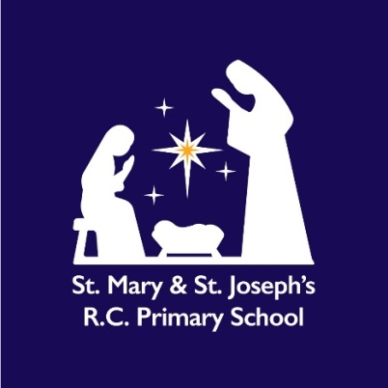
Relationships, Sex and Health Education (RSHE) Policy
Autumn2026

approveD September 2026

Mission Statement
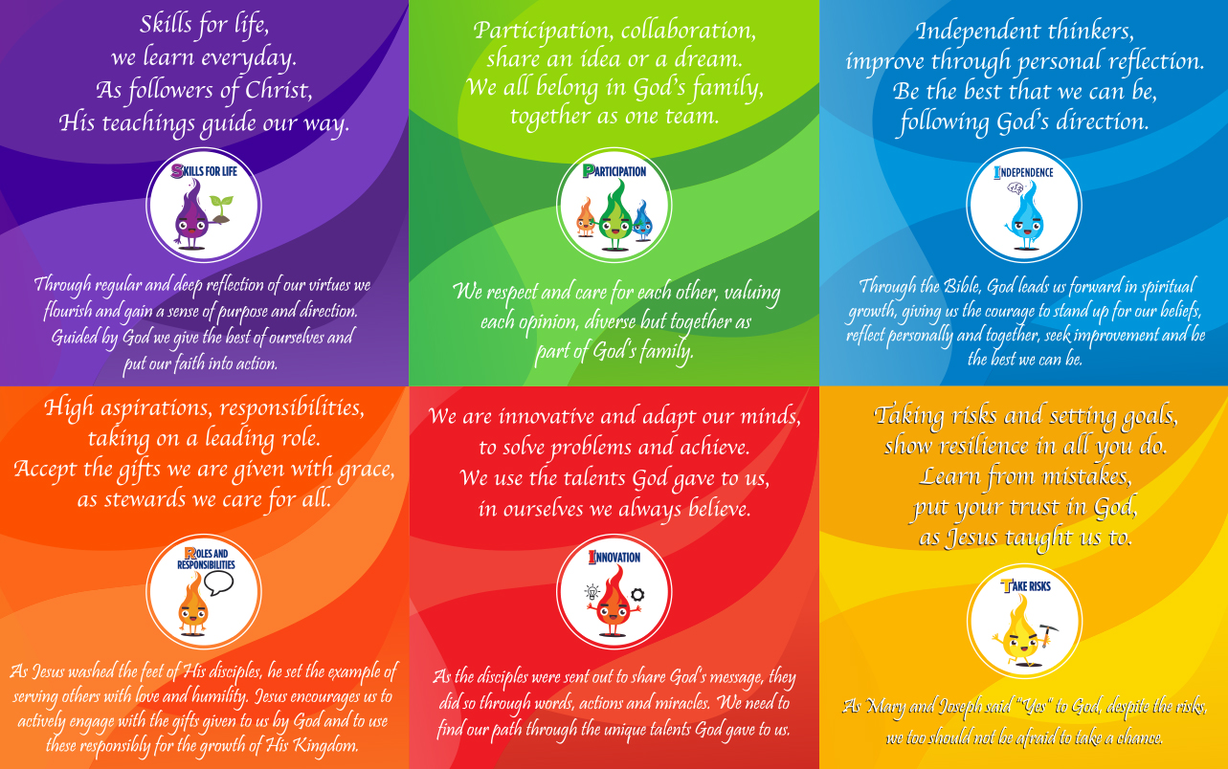
At St Mary and St Joseph’s Catholic Primary School, our mission is inspired by the Gospel and rooted in the teachings of the Catholic Church. We seek to enable every child to flourish spiritually, morally, socially, emotionally and academically so that they may "have life and have it to the full" (John 10:10).
We recognise that our school community includes families from a range of faith traditions, cultures and backgrounds. We value the contribution this diversity brings to our community and are committed to ensuring that every child feels welcomed, respected and included.
Our Relationships and Sex Education (RSE) programme is delivered within a Catholic framework of human dignity, respect, compassion and responsibility. It reflects both our Catholic character and our responsibility to prepare children to live positively and respectfully in modern Britain.
Consultation
This policy has been developed in consultation with:
- pupils through class discussions and pupil voice activities;
- parents and carers;
- teaching and support staff;
- governors;
- the Diocese;
- health professionals and external agencies where appropriate.
The views of all stakeholders have informed the development of this policy and the school's RSE curriculum.

Implementation and Review
This policy was implemented following consultation with governors during the Autumn Term 2026.
The policy will be reviewed annually by the Headteacher, RSE Lead and Governing Body to ensure that it remains:
- compliant with statutory requirements;
- reflective of current DfE guidance;
- aligned with diocesan expectations;
- responsive to the needs of pupils and families.

Dissemination
This policy will be:
- published on the school website;
- available from the school office upon request;
- shared with governors and staff;
- accessible to parents and carers.
Details of curriculum content and resources will also be available to parents on request.

Defining Relationships and Sex Education
The Department for Education states that children and young people need knowledge and skills that enable them to make informed decisions about their wellbeing, health and relationships.
High-quality RSE supports pupils to:
- develop positive relationships;
- understand respect, consent and personal boundaries;
- keep themselves safe online and offline;
- develop resilience and emotional literacy;
- understand physical and emotional development;
- prepare for life in an increasingly diverse society.
At St Mary and St Joseph’s Catholic Primary School, RSE is understood as part of the lifelong process of learning about relationships, human dignity, personal responsibility and healthy development.
As a Catholic school, we teach that every person is made in the image and likeness of God and is therefore worthy of dignity, respect and love.
Statutory Requirements
The school will meet all statutory requirements set out within:
- Relationships Education, Relationships and Sex Education (RSE) and Health Education Statutory Guidance (DfE, updated September 2026);
- Equality Act 2010;
- Keeping Children Safe in Education;
- National Curriculum Science requirements.
The statutory Relationships Education curriculum is compulsory for all pupils.
Parents retain the right to request withdrawal from any non-statutory sex education elements in accordance with current DfE guidance.
Rationale
"I have come that they may have life and have it to the full." (John 10:10)
As a Catholic school, we believe that every person is created in the image and likeness of God and is called to live in loving relationships with others.
Relationships and Sex Education contributes to the spiritual, moral, emotional, social and physical development of our pupils. It supports children in understanding themselves and others, developing healthy relationships and making safe and responsible choices.
Whilst our programme is rooted in Catholic teaching and values, we recognise and respect that members of our school community come from different faith backgrounds and life experiences. Teaching is therefore delivered in a manner which is inclusive, respectful and sensitive to the lived experiences of all pupils and families.
Our curriculum reflects both:
- the teachings and values of the Catholic Church;
- the realities of contemporary society and life in modern Britain.
Our curriculum prepares pupils for life in modern Britain by promoting respect for diversity, equality, democracy, inclusion and human dignity. Pupils learn to engage respectfully with people whose beliefs, values, cultures and backgrounds may differ from their own.
Curriculum Framework
The school uses a blended curriculum approach.
Ten:Ten Life to the Full
The Ten:Ten Life to the Full programme provides the principal resource for teaching Families and Relationships and the Catholic understanding of human dignity, vocation and family life.
Kapow PSHE
Kapow Primary PSHE resources are used to support wider personal development and statutory Health Education, including:
- health and wellbeing;
- mental health;
- keeping safe;
- living in the wider world;
- citizenship;
- economic wellbeing;
- online safety;
- personal development.
This combined approach ensures that statutory requirements are fully met while maintaining the Catholic character of the school.
Values and Virtues
Our RSE curriculum promotes the values and virtues that underpin Catholic life and learning:
- respect
- compassion
- kindness
- honesty
- integrity
- responsibility
- forgiveness
- justice
- faithfulness
- courage
Pupils are encouraged to understand that every person possesses inherent dignity and should be treated with care, respect and fairness.
British Values
The school actively promotes the fundamental British Values of:
- Democracy
- The Rule of Law
- Individual Liberty
- Mutual Respect
- Tolerance of those with different faiths and beliefs
These values are promoted through the Catholic life and mission of the school, the Religious Education curriculum, Relationships and Sex Education, PSHE, collective worship and the wider curriculum.
Through RSE, pupils learn to:
- respect differences between individuals and communities;
- value the opinions and beliefs of others;
- understand the importance of rights and responsibilities;
- develop confidence in expressing their own views respectfully;
- recognise the importance of fairness, equality and justice;
- understand how laws help to protect individuals and communities;
- contribute positively to school, local and wider communities.
As a Catholic school, we believe that the promotion of British Values is compatible with and strengthened by Catholic teaching on human dignity, the common good, solidarity and respect for all people.
Our curriculum prepares pupils for life in modern Britain by helping them to understand and appreciate the diverse society in which they live whilst remaining rooted in Gospel values.

Aims of RSE
In partnership with parents and carers, we aim to provide children with a positive and age-appropriate education about relationships and personal development.
The aims of our programme are to:
- develop self-worth and confidence;
- foster healthy and respectful relationships;
- promote emotional wellbeing;
- support safeguarding and personal safety;
- develop resilience;
- promote understanding of family life and community;
- enable pupils to recognise and challenge prejudice and discrimination;
- prepare pupils for the opportunities, responsibilities and experiences of later life.

Learning Objectives
Attitudes and Values
Pupils will develop:
- respect for themselves and others;
- appreciation of family life and relationships;
- responsibility for their actions;
- empathy and compassion;
- commitment to fairness and inclusion;
- confidence in their own identity and worth.
Personal and Social Skills
Pupils will develop the ability to:
- establish and maintain positive relationships;
- communicate effectively;
- recognise healthy and unhealthy behaviours;
- manage conflict appropriately;
- seek support when needed;
- assess and manage risk;
- stay safe online and offline;
- demonstrate resilience.
Knowledge and Understanding
Pupils will learn:
- about family life and friendships;
- about physical and emotional development;
- about puberty and growing up;
- how to keep safe;
- how laws help protect people;
- how to maintain physical and mental wellbeing;
- about diversity within communities and society.
Broad Curriculum Content
Families and Relationships
(Delivered primarily through Ten:Ten)
Children will learn about:
- family life;
- caring relationships;
- friendship;
- respect;
- belonging;
- conflict resolution;
- healthy and unhealthy relationships;
- online relationships;
- God's love for all people.
Health and Wellbeing
(Delivered primarily through Kapow)
Children will learn about:
- emotional wellbeing;
- mental health;
- resilience;
- healthy lifestyles;
- personal safety;
- healthy choices;
- growing and changing;
- puberty.
Living in the Wider World
(Delivered primarily through Kapow)
Children will learn about:
- citizenship;
- diversity and inclusion;
- rights and responsibilities;
- economic wellbeing;
- digital citizenship;
- respecting difference;
- contributing positively to society.
- Democracy and pupil voice
- Rules, laws and responsibilities
- Individual rights and freedoms
- Respect for different faiths and worldviews
- Community participation
- Active citizenship

Inclusion and Adaptive Teaching
The school is committed to ensuring that all pupils can access RSE.
Teaching will be carefully adapted to meet the needs of:
- pupils with SEND;
- disadvantaged pupils;
- vulnerable pupils;
- pupils requiring additional support.
We recognise that pupils come from a variety of:
- family structures;
- faith traditions;
- cultures;
- backgrounds and experiences.
Teaching will reflect this diversity whilst remaining faithful to the Catholic ethos of the school.
All pupils will be encouraged to recognise and challenge bullying, discrimination and prejudice.
Equality Statement
In accordance with the Equality Act 2010, we are committed to promoting equality of opportunity and fostering good relations between all members of our community.
RSE will:
- promote respect for all;
- challenge prejudice and discrimination;
- reflect the diversity of society;
- support inclusion and belonging;
- uphold the dignity of every individual.
Teaching will always be age-appropriate and delivered sensitively.

Parents and Carers
We recognise parents and carers as the first educators of their children and value the partnership between home and school.
Parents and carers will:
- be consulted regarding policy review;
- have access to curriculum information;
- be able to view resources used within RSE;
- receive notification before sensitive learning takes place;
- be invited to information sessions where appropriate.
The school will support parents in discussing relationships, health and wellbeing with their children.
Right to Withdraw
Parents have the right to request withdrawal from any non-statutory sex education elements of the programme.
Requests should be made in writing to the Headteacher. (Appendix 1)
There is no right to withdraw from:
- statutory Relationships Education;
- Health Education;
- National Curriculum Science.
Safeguarding
RSE plays a vital role in safeguarding children.
Through RSE pupils learn:
- how to stay safe;
- how to recognise harmful situations;
- how to seek help;
- how to identify trusted adults.
Any safeguarding concerns disclosed during lessons will be managed in accordance with the school's Safeguarding and Child Protection Policy.
Staff cannot offer unconditional confidentiality where there is a safeguarding concern.

Managing Questions and Sensitive Issues
The school seeks to create a safe environment where pupils:
- feel able to ask questions;
- are treated respectfully;
- can explore issues in an age-appropriate way.
Teachers will:
- establish clear ground rules;
- answer questions honestly and appropriately;
- use professional judgement when responding;
- identify when a question requires individual follow-up rather than class discussion.

Teaching and Learning Approaches
A range of teaching strategies will be used including:
- discussion;
- reflection;
- role play;
- scenario work;
- storytelling;
- group work;
- collaborative learning;
- problem solving;
- video and media resources;
- pupil voice activities.
Teaching will be engaging, inclusive and developmentally appropriate.
Assessment
Assessment will be undertaken through:
- teacher observation;
- pupil discussion;
- self-assessment;
- reflection activities;
- recorded work where appropriate.
Assessment will focus on pupils' knowledge, understanding and application of learning rather than personal beliefs or experiences.
Roles and Responsibilities

Governing Body
The Governing Body will:
- approve and monitor this policy;
- ensure statutory compliance;
- ensure parental consultation;
- monitor curriculum provision;
- support Catholic Life and Mission.
Headteacher
The Headteacher has overall responsibility for:
- implementation of the policy;
- staff training;
- curriculum compliance;
- communication with parents and governors.
RSE Lead
The RSE Lead will:
- coordinate provision;
- support staff;
- monitor quality of teaching;
- organise resources and training.
Staff
All staff are responsible for:
- promoting positive relationships;
- supporting pupil wellbeing;
- implementing the curriculum effectively;
- upholding the Catholic ethos of the school.

Use of External Visitors
External visitors may be used to enrich learning but will not replace teacher-led provision.
All visitors will:
- work within school policies;
- support the school's ethos and values;
- follow safeguarding procedures;
- be appropriately vetted where required.
Teachers will remain responsible for the learning taking place during such sessions.
Relationship to Other Policies
This policy should be read alongside:
- Safeguarding and Child Protection Policy
- Behaviour Policy
- Anti-Bullying Policy
- Equality Policy
- Online Safety Policy
- SEND Policy
- PSHE Policy
- Religious Education Policy

Monitoring and Evaluation
Monitoring will take place through:
- learning walks;
- lesson observations;
- curriculum reviews;
- pupil voice;
- parent feedback;
- governor monitoring activities.
The effectiveness of the programme will be reviewed annually and reported to governors.

Reviewed: September 2026
RSE Lead: K.Boyle
Headteacher: A.Thomson
Approved by Governing Body: September 2026
Chair of Governors: M. Ashcroft
Date: September 2026
Review Date: September 2027

Appendix 1
Parent Right to Withdraw a Child from Sex Education Request Form
Information for Parents and Carers
St Joseph's Catholic Primary School is a Catholic school serving a diverse community. Relationships and Sex Education (RSE) is taught within the context of the Catholic faith, promoting the dignity of every person, respectful relationships, family life, compassion, inclusion and mutual respect.
The school uses the Ten:Ten Life to the Full programme to support the delivery of Relationships and Sex Education. We recognise and value the contribution of parents and carers as the first educators of their children and seek to work in partnership with families from all faith backgrounds and those with no religious faith.
Under current statutory guidance, parents have the right to request that their child be withdrawn from some or all of any sex education taught beyond the National Curriculum for Science. Parents do not have the right to withdraw their child from:
Relationships Education;
Health Education;
National Curriculum Science.
Parents and carers are encouraged to discuss any questions or concerns with the Headteacher before submitting a request.

Parent Request to Withdraw from Sex Education
Child's Details
Child's Full Name: ___________________________________________
Date of Birth: ______________________________________________
Class/Year Group: ___________________________________________

Parent/Carer Details
Name of Parent/Carer: _______________________________________
Relationship to Child: ______________________________________
Telephone Number: __________________________________________
Email Address: _____________________________________________

Withdrawal Request
I wish to request that my child be withdrawn from the sex education elements of the school's Relationships and Sex Education programme that are delivered beyond the requirements of the National Curriculum for Science.
Please indicate, if known, the content or lessons from which you wish your child to be withdrawn:

Reason for Request
Please outline the reason for your request:

Parent/Carer Declaration
I confirm that:
☐ I have read the school's Relationships and Sex Education Policy.
☐ I understand that my child cannot be withdrawn from Relationships Education.
☐ I understand that my child cannot be withdrawn from Health Education.
☐ I understand that my child cannot be withdrawn from National Curriculum Science.
☐ I understand that I will be offered an opportunity to discuss this request with the school.
☐ I understand that suitable supervision arrangements will be made for my child if a withdrawal request is agreed.
Parent/Carer Signature: _______________________________________
Date: ______________________________________________________

School Use Only
Date Request Received: _______________________________________
Date of Meeting with Parent/Carer: _____________________________
Staff Present: _______________________________________________
Outcome
☐ Request Agreed
☐ Request Agreed in Part
☐ Request Not Applicable (content forms part of statutory curriculum)
Notes

Headteacher Signature: _______________________________________
Date: ______________________________________________________

Review Date (if applicable): _________________________________

