

Writing

- Use subordinate clauses to write complex sentences.
- Use passive voice where appropriate.
- Use expanded noun phrases to convey complicated information concisely (e.g. The fact that it was raining meant the end of sports day).
- Use a sentence structure and layout matched to requirements of text type.
- Use semi-colon, colon or dash to mark the boundary between independent clauses.
- Use colon to introduce a list and semi colon within a list.
- Use correct punctuation of bullet points.
- Use hyphens to avoid ambiguity.
- Use full range of punctuation matched to requirements of text type.
- Use wide range of devices to build cohesion within and across paragraphs.
- Use paragraphs to signal change in time, scene, action, mood or person.
- Write legibly, fluently and with increasing speed.
Reading

- Refer to text to support opinions and predictions.
- Give a view about choice of vocabulary, structure, etc.
- Distinguish between fact and opinion.
- Appreciate how a set of sentences has been arranged to create maximum effect.
- Recognise:
  - complex sentences with more than one subordinate clause
  - phrases which add detail to sentences
- Explain how a writer has used sentences to create particular effects.
- Skim and scan to aide note-taking.

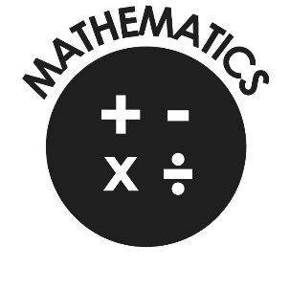
Mathematics

- Use negative numbers in context and calculate intervals across zero.
- Compare and order numbers up to 10,000,000.
- Identify common factors, common multiples and prime numbers.
- Round any whole number to a required degree of accuracy.
- Identify the value of each digit to 3 decimal places.
- Use knowledge of order of operations to carry out calculations involving four operations.
- Multiply 4-digit by 2-digit
- Divide 4-digit by 2-digit
- Add and subtract fractions with different denominators and mixed numbers.
- Multiply simple pairs of proper fractions, writing the answer in the simplest form.
- Divide proper fractions by whole numbers.
- Calculate percentage of whole number.

St Mary and St Joseph’s RC
Primary School



End of Year Expectations
for Year 6

This booklet provides information for parents and carers on the end of year expectations for children in our school. The National Curriculum outlines these expectations as being the minimum requirements your child must meet in order to ensure continued progress.

All the objectives will be worked on throughout the year and will be the focus of direct teaching. Any extra support you can provide in helping your children to achieve these is greatly valued.

If you have any queries regarding the content of this booklet or want support in knowing how best to help your child please talk to your child’s teacher.

