St Mary and St Joseph’s RC Primary School
Being different, Belonging Together in the family of God
St Mary and St Joseph’s RC Primary School

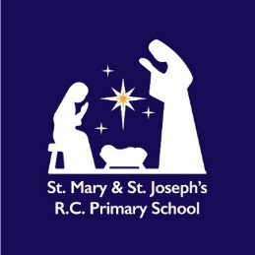
Religious Education Policy

St Mary and St Joseph’s RC Primary School
Review Date: Autumn 2026 (to be updated to reflect the changes in RE when a model policy has been provided by the Diocese of Salford.)
Religious Education Policy
Our Mission Statement:

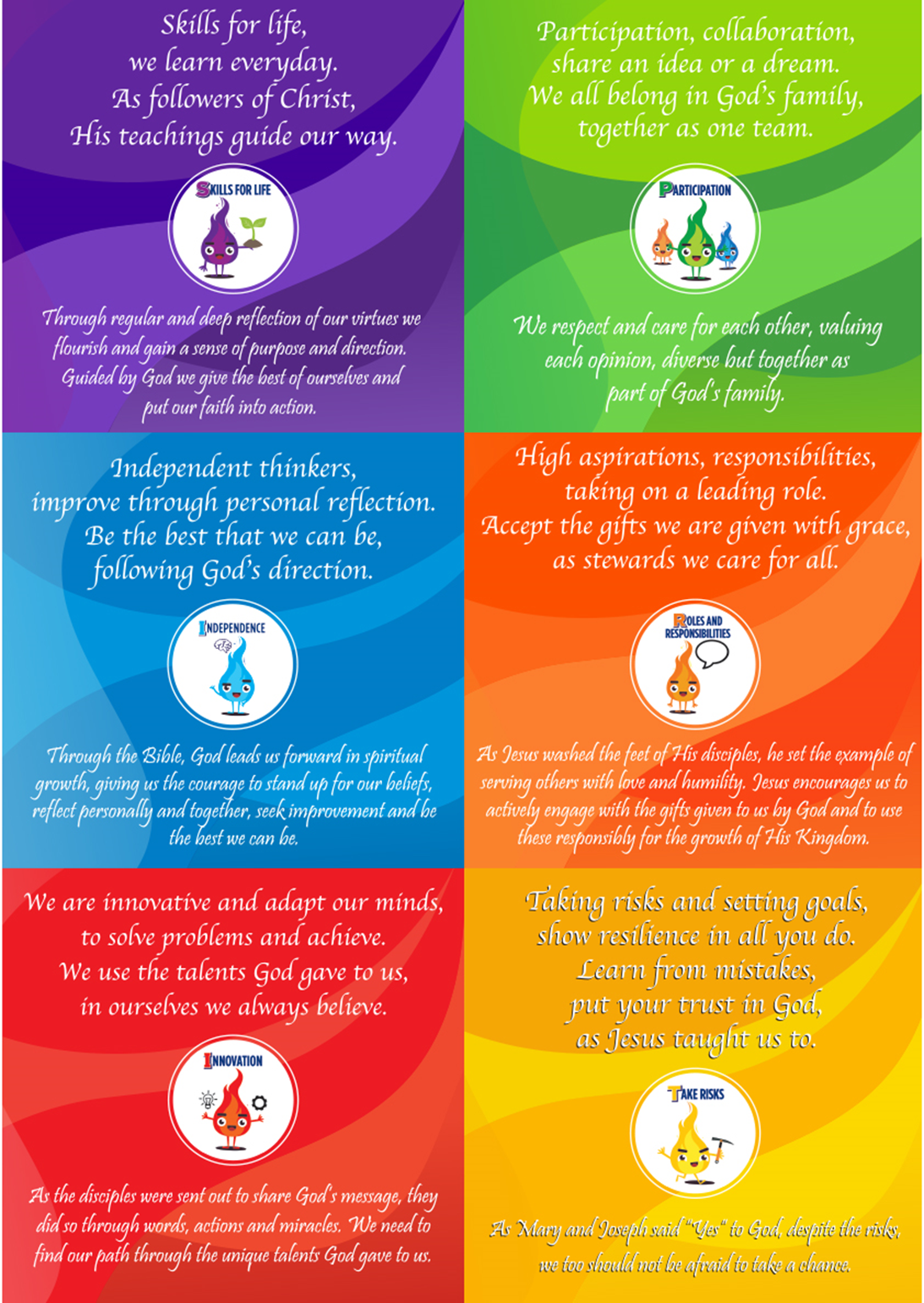

At St Mary and St Joseph’s Catholic Primary School, we seek to grow together in God’s love. We are committed to providing a Christ-centred education that nurtures the whole child – spiritually, morally, intellectually, socially, emotionally, and physically – rooted in the Gospel values and the teachings of the Catholic Church.
"Catholic schools are communities of faith and learning, devoted to the education of the whole person."
(RED, Introduction, p.4)
Rationale of Religious Education.
Religious Education (RE) is at the heart of the Church’s mission in education. It is a core subject within the curriculum of a Catholic school and is vital to the holistic development of every child.
“Religious Education in Catholic schools aims to promote religious literacy and formation in the Catholic faith.”
(RED, Introduction, p.4)
At St Mary and St Joseph’s, RE enables pupils to:
- Encounter Jesus Christ and grow in understanding of His message
- Explore, question and respond to the mystery of faith
- Understand and apply the teachings of the Church
- Develop the skills to think ethically and theologically
- Respect and engage with other religions and worldviews
As the Religious Education Directory (RED) (2023) states:
“The outcome of excellent Religious Education is religiously literate and engaged young people who have the knowledge, understanding and skills to reflect spiritually, think ethically and theologically, and who are aware of the demands of religious commitment in everyday life.”
(RED, Introduction, p.6)
Intent
It is our aim at St. Mary and St Joseph’s to provide a Religious Education (R.E.) which provides all children with opportunities to learn and achieve whilst developing the spiritual, moral, social and cultural aspects of their lives.
It is through the teaching of R.E. that we aim to explicitly develop a knowledge and understanding of the teachings of the Catholic faith and practice whilst developing respect for all faiths within our school and the wider community. Our Religious Education provides opportunities to learn about and celebrate the Gospel values and virtues of the Catholic Church, which underpins everything we do.
In line with the RED and Diocesan guidance, our Religious Education curriculum intends to:
- Provide systematic and rigorous knowledge and understanding of the Catholic faith for all pupils, whatever their background
- Foster a deep knowledge and understanding of Sacred Scripture, Church teaching, liturgy, and the Sacraments
- Enable pupils to develop a personal relationship with God
- Offer opportunities to explore the moral and social teaching of the Church
- Equip children to engage in respectful dialogue with people of other faiths and worldviews
We are committed to:
- Supporting pupils’ spiritual, moral, social, cultural, and emotional development
- Developing pupils' religious literacy through structured learning and critical engagement
- Helping pupils to live out Gospel values in all aspects of their lives
“Religious Education in the Catholic school is primarily educational in nature. It is never simply catechesis, or evangelisation, but contributes to both.”
(RED, Introduction, p.6)
Objectives:
In R.E:
We follow the six Branches as required by RED (Religious Education Directory):
  - Creation and Covenant
  - Prophecy and Promise
  - Galilee to Jerusalem
  - Desert to Garden
  - To the Ends of the Earth
  - Dialogue & Encounter (Other Faiths / Worldviews)
- We will teach these through the Knowledge Lenses: Hear, Believe, Celebrate, Live, Encounter, Dialogue.
- Lessons are shaped using the Ways of Knowing, enabling pupils not simply to know facts but to understand, discern, respond, and apply their learning.
- Lighting the Path (OUP) will be the core scheme across EYFS and KS1. Salford Diocese pilot resources will be integrated in those year groups where the Diocese is already trialling them (KS2), with full roll-out of the Lighting the Path scheme by September 2026, when implementation of the new Religious Education Directory, will be statutory.
- We use Religious Education as an opportunity to apply learning from lessons through discussion and activities focused on skills outlined within the national age-related standards for R.E.
- We learn vocabulary relevant to the area of study, developing a knowledge and understanding of words important to the topic and linked to skills within the age-related standards.
- We develop knowledge and understanding of God with Jesus being central to the beliefs of Christians/Catholics.
- We experience lessons which encourage learning through creative activities, stories, art, drama, people/visitors and objects/symbols.
- We explore a range of other faiths and their traditions and beliefs.
- We develop an awareness of their personal faith and a developing sense of: - self-esteem - awe and wonder - transcendence - respect for the beliefs and practices of others - personal responsibility - belonging to a community - personal and community responsibility for others
Implementation of Religious Education
In accordance with the Bishops’ Conference guidelines:
- RE is allocated 10% of the taught curriculum (not including collective worship)
  - EYFS and KS1: approx. 2 hours 15 minutes weekly
  - KS2: approx. 2 hours 30 minutes weekly
“Religious Education is to be regarded as a core subject, in the same way as English or Mathematics... It must be given its full share of curriculum time.”
(RED, Section 2.6, p.9)

Teaching and Planning

To achieve our aims in Religious Education (RE), we currently use the Lighting the Path programme in EYFS and Key Stage 1. For Key Stage 2, following guidance from the Diocese of Salford, we are trialling diocesan resources as part of the phased implementation of the new Religious Education Directory (RED). By Summer 2026, all classes will transition to the Lighting the Path scheme. The new RED becomes statutory from September 2026.

RE is central to school life, taught in accordance with the RED and the Catechism of the Catholic Church, supporting children in learning about the Catholic faith and living it out daily.

Curriculum Structure
Our curriculum follows the six key themes from the RED: Hear, Believe, Celebrate, Live, Encounter, and Dialogue. These themes guide children’s learning about Scripture, Church teachings, prayer, and Christian living. RE lessons align with the Liturgical Year to connect with Church seasons and celebrations.

EYFS and Key Stage 1
From September 2025, EYFS and KS1 pupils will follow the Lighting the Path – Source to Summit programme, designed to meet RED requirements. This resource encourages young children to explore faith through stories, prayer, reflection, and learning about Jesus and the Church. In EYFS, RE is integrated with the Early Learning Goals, supporting overall development.

Key Stage 2
Currently, KS2 pupils use diocesan-approved RE resources that deepen understanding of Catholic beliefs, Sacraments, and Christian living. Preparation is underway to adopt the Lighting the Path – Source to Summit programme from September 2026 to ensure consistency across the school.

Learning About Other Faiths
At various points during the year, children learn about other world religions through age-appropriate units from the Cornerstones curriculum. This promotes respect and understanding of different faiths and cultures, reflecting the Church’s teaching on interfaith dialogue.

Planning and Assessment
RE lessons are planned to suit children’s age and developmental stage. Assessment in EYFS is linked to Early Learning Goals, while in KS1 and KS2 it is based on RED outcomes. Both informal (ongoing) and formal (end-of-unit) assessments help track progress and inform future planning.

Staff Training and Monitoring
Teachers receive regular training to enhance confidence and effectiveness in delivering RE. The RE subject leader collaborates with school leadership and the Diocese to monitor the quality of teaching through planning reviews, lesson observations, pupil feedback, and staff support.
Assessment
RE is assessed formatively and summatively, using criteria aligned with the RED's expectations using a combination of teacher assessment and completion of specific provided tasks within the RE programme.
“Religious Education should be assessed with the same rigour as other core subjects.”
(RED, Section 2.8, p.10)
Assessment focuses on three domains reflected in pupil outcomes:
- Understanding – factual knowledge and comprehension (blue)
- Discerning – critical thinking and evaluation (pink)
- Responding – personal response and reflection (grey)
Pupils are assessed at three attainment levels:
- Has Not Met
- Expected
- Greater Depth
Greater Depth is achieved through independent demonstration of Discern and Respond skills beyond surface-level understanding.
Assessment Tools
- Tracking system used across the school for all year groups to monitor progress across school.
- Moderation conducted termly with staff and across schools (SIG groups)
- Check-in and check-out tasks used to monitor progress, where provided within units.

Monitoring, Recording and Reporting:
- An in-house moderation of pupils’ books is held twice a year with school staff. In the Autumn and Summer terms.
- Monitoring of teaching and learning through lesson observation and learning walks is included in the school’s annual monitoring schedule. Regular book looks by the RE Lead/SLT take place each half term to ensure high standards are maintained.
- Progress and achievements which reflect pupil’s knowledge and understanding, are recorded and monitored on the school assessment tracker for R.E.
- Progress and achievement in Religious Education is reported to Governors in the annual report written by the subject lead.
- Progress and achievement in Religious Education is reported to parents/carers in a written report at the end of each academic year.
SEND
At St Mary and St Joseph’s we believe in the value of each individual, as a child of God. The school therefore, welcomes pupils with Special Educational Needs. In our school, we teach R.E. to all children, whatever their ability. When teaching R.E, we ensure that we provide a range of learning opportunities matched to meet the needs of all our children. A variety of teaching and learning strategies will be used from across the curriculum adapted appropriately to the needs and learning styles of pupils.
The ‘Lighting the Path’ programme provides additional SEND resources which can be used to adapt teaching where required.
Inclusion and Equality
The governing body have wider responsibilities under the Equalities Act 2010 and will ensure that our school strives to do the best for all of the pupils. All pupils in our school, irrespective of ability, faith and background will have appropriate access to the Religious Education programme.
Resources
The ‘Lighting the Path’ programme and resources provided by Salford Diocese provides example scripture quotes, stories, images and questions.
Where scripture is used during the teaching of RE, we encourage the use of age-appropriate Bibles, available in all classes, so that children understand and are familiar with the sacred text it has come from whilst developing an understanding of the context for beliefs and learning. The new RED recommends the English Standard Version of the Bible and classes have these too.
Within school children can access a range of resources and artefacts for a variety of religions. We encourage a hands-on approach to R.E. so that children are able to see how artefacts are used in different religions whilst developing an understanding and respect for their importance and religious value.
Our parish priest (Fr G Barry) is a regular visitor in school and is always willing to work with classes, sharing his own faith and experiences with them.
Staff Formation
All teachers of RE are:
- Actively supportive and exemplify the principles of the Catholic faith in their teaching practice, regardless of their personal faith background
- Given dedicated planning time for RE each term
- Supported by the RE Lead for subject knowledge and planning
- Involved in ongoing CPD, including:
  - Diocesan training (e.g. Salford Diocese courses)
  - Staff meetings
  - SIG collaboration with other Catholic schools
“All those who teach Religious Education in Catholic schools must have suitable qualifications and be prepared to undertake ongoing formation.”
(RED, Section 2.5, p.8)

Impact
R.E. at St Mary and St Joseph’s provides children with a knowledge and understanding of the Catholic faith whilst providing opportunities to reflect upon their own personal faith and spirituality. Through assessment children progress and achieve within the subject at a level personal to them. The range of teaching styles used, allows opportunities for all children to access and engage with the R.E. curriculum. All children contribute to all areas of the Catholic life of our school regardless of their own faith background. Children at St Mary and St Joseph’s develop respect and understanding for all religions and beliefs within our school and the wider community.

Role of the RE Lead
The RE Subject Leader (A-M Parker), is responsible for the strategic leadership and development of Religious Education across the school. This role ensures that RE is delivered in line with the expectations of the Religious Education Directory (RED), diocesan guidance, and the school's Catholic ethos. Key responsibilities include:
- Strategic Leadership and Curriculum Implementation
The RE Lead is responsible for leading the implementation of the Religious Education Directory (RED) and the diocesan programme Lighting the Path. This includes ensuring that the curriculum is theologically sound, progressive across key stages, and reflective of the school’s Catholic identity.
- Monitoring and Improving Teaching and Learning
The RE Lead monitors the quality of teaching and learning through lesson observations, work scrutiny, pupil voice, and planning reviews. Findings are used to identify strengths and areas for development, with a focus on raising standards and ensuring consistency across the school.
- Staff Development and Support
The RE Lead provides guidance and support to colleagues in the effective delivery of RE. This includes leading subject-specific CPD, supporting planning and assessment, mentoring new staff, and promoting high standards of pedagogy and subject knowledge.
- Assessment and Curriculum Development
The RE Lead oversees the planning and sequencing of the RE curriculum in line with diocesan requirements. They ensure appropriate assessment systems are in place, and that data is used effectively to inform teaching, identify gaps, and support pupil progress.
- Liaison with the Diocese and Wider Networks
The RE Lead attends relevant Diocesan training and briefings and disseminates updates to staff. They actively engage with diocesan and local networks to share and implement best practice, and to ensure the school remains compliant with current expectations.
- Accountability and Reporting
The RE Lead provides regular reports to the Senior Leadership Team and Governors, evaluating the impact of RE provision and progress against the School Development Plan. They play a key role in ensuring RE contributes meaningfully to the Catholic life of the school and to pupils’ spiritual, moral, social, and cultural development

Presented to governors: Autumn 2025
To be reviewed: Autumn 2026
*(N.B. This policy will be updated and amended, to reflect changes in the new Religious Education Directory as they are made and implemented with the guidance from the Diocese of Salford and the approval of Governors.)

