
St Mary and St Joseph’s RC Primary School

Prayer and Liturgy policy
This prayer and liturgy policy has been approved and adopted by the governing body on
February 2026 and will be reviewed February 2027
Signed by the Chair of Governors: M Ashcroft
Signed by the Headteacher: A Thomson

Our Mission Statement:

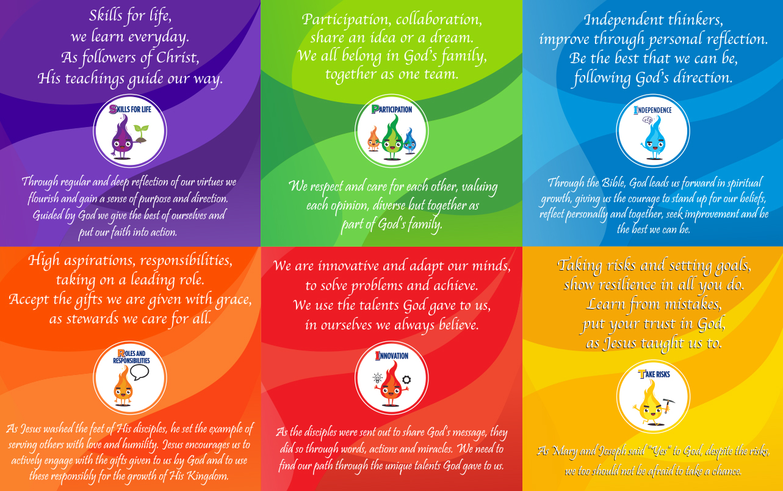
1. The context of this prayer and liturgy policy
‘The celebration of Catholic liturgies and prayers as an integral part of the learning and
teaching should enable the school community to become reflective, experience the
presence of God and should develop a mature spiritual life.’ (Marcus Stock (2012), Christ
at the Centre, Catholic Truth Society, 23.)

2. Statement of requirement
The law requires all maintained Catholic schools to provide an act of daily collective
worship (prayer and liturgy) for all pupils (Section 70, 1988 Education Act) that is in accordance with the rites, practices, disciplines, and liturgical norms of the Catholic Church (School Standards and Framework Act 1998, schedule 20; 70

The law requires all maintained schools to recognise and respect that parents have the
legal right to withdraw their children up to the age of 16 from prayer and liturgy (School
Standards and Framework Act 1998, s.71(1A)).

The school’s provision for prayer and liturgy will fulfil pupils’ entitlement to experience the
range of liturgical treasures of the Church, including a shared repertoire of prayers and
liturgical music with which pupils in the school will be familiar.

Prayer and liturgy are not designated curriculum time. In the context of the Catholic school,
this means that times of prayer and liturgy are not considered to be part of the allocation
of curriculum time for Religious Education.

3. Responsibility
(a) Governance
The governors, as guardians of the Catholic school’s life and mission, have a responsibility
to ensure that:
• prayer and liturgy are central to the Catholic life of the school and therefore are in line
with the guidance set out by the Prayer and Liturgy Directory
• A.Thomson, R.Love and A-M.Parker are responsible for prayer and liturgy in the school.
• the prayer and liturgy policy is updated regularly and shared with all stakeholders
• there is a budget for prayer and liturgy that reflects its centrality to the life of a
Catholic school.

(b) Headteacher and Deputy Headteacher
A. Thomson (headteacher) and R.Love (deputy headteacher), as the spiritual leaders of the school, as a Catholic community, ensure that:
• prayer and liturgy are central to the Catholic life of the school and therefore are in line
with the guidance set out by the Prayer and Liturgy Directory
• they work in partnership with the leader(s) for prayer and liturgy
• those responsible for prayer and liturgy in the school have been given appropriate
training and formation to ensure that all guidance is followed and adhered to
• there are suitable resources for prayer and liturgy in the school.

(c) Prayer and Liturgy Coordinator(s)
A-M Parker as prayer and liturgy coordinator with A. Thomson (Headteacher) and R.Love (Deputy Headteacher) will ensure that:
• prayer and liturgy are central to the Catholic life of the school and therefore are in line
with the guidance set out by the Prayer and Liturgy Directory
• there is an Annual Plan of Provision for prayer and liturgy across the school year which
identifies liturgical seasons and key celebrations, as well as opportunities for the
celebration of the Sacraments
• there is daily planned prayer for all pupils, appropriate to age and ability, as outlined in
the Prayer and Liturgy Directory
• pupils are supported in their liturgical formation to take an active role in the planning,
preparation, and delivery of prayer and liturgy according to their age and capacity,
and in a manner which facilitates their progressive participation
• resources to support the planning of prayer and liturgy are appropriate and readily
available to staff and pupils
• induction on prayer and liturgy takes place for new members of staff as required
• staff have access to effective training and formation opportunities
• monitoring and evaluation of prayer and liturgy take place regularly and feed back into
planning for future liturgies
• monitoring of prayer and liturgy is reported to the headteacher and governing body to
support whole-school development and the Catholic life of the school
• there is collaboration with local clergy and parishes
• liaison with the Diocesan Advisory Service and others is maintained to ensure they keep
updated with best practice.

4. Overview of prayer and liturgy provision
- Weekly
- Monday: Ten:Ten Whole School Assembly linked to the Sunday’s Gospel or a Liturgical Time – Led by AT, RL, AMP (GIFT team to support for example by leading the prayers or reading the Gospel)
- Tuesday: Virtues/Values themed Whole school assembly. (pupil’s involved with the leading or setting up of the assembly).
- Wednesday: Class Prayer for example reflective prayer, meditation etc…based upon the Gospel/Virtues/Values theme of the week or Liturgical time, Wednesday Word led by the pupils in KS2, pupils in EYFS and KS1 to have involvement in creating a focal space or sharing a prayer etc...
- Thursday: Class assemblies for whole school or Praise through Song
- Friday: Celebration – S.P.I.R.I.T assembly. (G.I.F.T Team to lead the prayers)

- Eucharistic Celebration of the Mass in school will be celebrated once per half term as far as possible and at significant times or seasons within the liturgical Year as a whole school.
- Whole school stations of the Cross will be said during Lent.
- Opportunities for children to participate in the Rosary will made during the months of May and October and reconciliation services will be led by the GIFT team during Lent and Advent

All children have a prayer journal book in which to write their own personal prayers or reflections to share as part of their daily class prayer time, in EYFS and Year 1 this may be done as a class using children’s ideas and reasons to pray. Pupils throughout school will also learn the common prayers including: The Sign of the Cross, Our Father, Hail Mary, Glory Be, Grace before meals and Grace after meals, said as part of daily prayer. Children will also be supported to know the Mass responses providing the opportunity for them to participate as appropriate. In addition, KS2 will also know the Angel of God prayer and the ‘Eternal Rest’ to say at times when we pray for those who have died.
The Apostles Creed, The Magnificat, and the ‘Come Holy Spirit’ prayer will be taught and made known to children through the RE curriculum.
5. Resourcing
Prayer and liturgy are central to the school’s understanding of itself as a Catholic school,
and this is reflected in the annual budget allocation and available resources, including
staff time, chaplaincy provision, and dedicated spaces for prayer and liturgy. The Catholic
character of the school is reflected in religious artefacts and images on display throughout
the building. Dedicated spaces for prayer and liturgy will be furnished and maintained as
such, and updated to reflect the Church’s liturgical season.
Staff training and formation costs will be funded separately to ensure that all staff are able to fulfil their responsibility to contribute to the prayer and liturgical life of the school.

6. Training and formation
All new staff will be supported during induction and beyond, so that they fully understand
the responsibility they carry within their individual role for leading prayer and liturgy in the
school. Any individual training needs will be identified and addressed through training and
formation. There will also be the opportunity for whole-staff professional development at
least once a year, so that all staff understand the importance of prayer and liturgy and
relevant staff are well supported to lead as required.

7. Monitoring and evaluation
Monitoring and evaluation of the quality and impact of prayer and liturgy will take place
annually, with staff and pupils. Areas for development will be identified and issues raised will be
actioned and evidenced as appropriate.

8. Review
The policy will be reviewed as part of the regular cycle of policy review conducted by
the governors.

