Week  Commencing | Monday | Tick Option | Tuesday | Tick Option | Wednesday | Tick Option |  | Thursday |  | Tick Option | Friday | Tick Option
Week 1 | Margarita Pizza  with Coleslaw and a choice of Salad |  | Bolognaise Pasta served with sliced Garlic Bread  Non Halal  Halal |  | Chicken Tikka Fillets (Strips) with flavoured Rice served a Naan-Bread  Non Halal  Halal |  |  | Sausage and Mash served with Yorkshire pudding and Beans  Non Halal  Halal |  |  | Fish Fingers with Chipped Potatoes and Garden Peas
Week 1 | Jacket potato with a choice of fillings  Beans  Cheese  Tuna | Circle your choice of filling | Jacket Potato with a choice of fillings  Beans  Cheese  Tuna | Circle your choice of filling | Jacket potato with a choice of fillings  Beans  Cheese  Tuna | Circle your choice of filling |  | Jacket potato with a choice of fillings  Beans  Cheese  Tuna |  | Circle your choice of filling | Omelette  Or Poached egg  Served with Chipped Potatoes and Beans | 
Week 1 | Sandwich with a choice of fillings  Ham  Cheese  Tuna  Egg  Served with Tortilla Chips | Circle your choice of filling | Sandwich with a choice of fillings  Ham  Cheese  Tuna  Egg  Served with Tortilla Chips | Circle your choice of filling | Sandwich with a choice of fillings  Ham  Cheese  Tuna  Egg  Served with Tortilla Chips | Circle your choice of filling |  | Sandwich with a choice of fillings  Ham  Cheese  Tuna  Egg  Served with Tortilla Chips |  | Circle your choice of filling | Sandwich with a choice of fillings  Ham  Cheese  Tuna  Egg  Served with Tortilla Chips | Circle your choice of filling
Dessert | Yoghurt  Fresh fruit |  | Yoghurt  Fresh fruit |  | Yoghurt  Fresh fruit |  |  | Yoghurt  Fresh fruit |  |  | Yoghurt  Fresh fruit
 | Homemade Biscuit |  | Doughnuts |  | Homemade Biscuit |  |  | Decorated Cake |  |  | Ice Cream
Also available daily: fresh fruit, fresh bread & mixed salad bar with Salmon fillets. Fruit juice, semi-skimmed milk or fresh water

Week  Commencing | Monday | Tick Option | Tuesday | Tick Option | Wednesday | Tick Option |  | Thursday |  | Tick Option | Friday | Tick Option
Week 2 | Quorn Hotdog served with Potato Wedges and Mixed Salad |  | Beef Lasagne with a slice of Garlic Bread  Non Halal  Halal |  | Pizza Whirls served with Criss cross potatoes |  |  | Chicken Pasta in a Creamy Tomato Sauce served with Mixed Vegetables  Non Halal  Halal |  |  | Fillet of Fish in a Bun served with Skinny Fries and Sweetcorn/Peas
Week 2 | Jacket potato with a choice of fillings  Beans  Cheese  Tuna  Allergens  F, M and D | Circle your choice of filling | Jacket potato with a choice of fillings  Beans  Cheese  Tuna  Allergens  F, M and D | Circle your choice of filling | Jacket potato with a choice of fillings  Beans  Cheese  Tuna  Allergens  F, M and D | Circle your choice of filling |  | Jacket potato with a choice of fillings  Beans  Cheese  Tuna  Allergens  F, M and D |  | Circle your choice of filling | Omelette  Or Poached egg  Served with Chipped Potatoes and Beans  Allergens M, E and D
Week 2 | Sandwich with a choice of fillings  Ham  Cheese  Tuna  Egg  Served with Tortilla Chips | Circle your choice of filling | Sandwich with a choice of fillings  Ham  Cheese  Tuna  Egg  Served with Tortilla Chips | Circle your choice of filling | Sandwich with a choice of fillings  Ham  Cheese  Tuna  Egg  Served with Tortilla Chips | Circle your choice of filling |  | Sandwich with a choice of fillings  Ham  Cheese  Tuna  Egg  Served with Tortilla Chips |  | Circle your choice of filling | Sandwich with a choice of fillings  Ham  Cheese  Tuna  Egg  Served with Tortilla Chips | Circle your choice of filling
Dessert | Yoghurt  Fresh fruit |  | Yoghurt  Fresh fruit |  | Yoghurt  Fresh fruit |  |  | Yoghurt  Fresh fruit |  |  | Yoghurt  Fresh fruit
 | Homemade Biscuit |  | Decorated Bun |  | Homemade Biscuit |  |  | Raspberry Bun |  |  | Ice Cream
Also available daily: fresh fruit, fresh bread & mixed salad bar with Salmon fillets. Fruit juice, semi-skimmed milk or fresh water

Week  Commencing | Monday | Tick Option | Tuesday | Tick Option | Wednesday | Tick Option |  | Thursday |  | Tick Option | Friday | Tick Option
Week 3 | Cheese Whirls with Cubed Roasted Potatoes and a Choice of Seasonal Vegetables |  | Quorn Burritos with Potatoes and Salad |  | Cheeseburger served on a bun with Skinny Fries  Non Halal  Halal |  |  | Chicken Kebab with Potato Wedges and Salad  Non Halal  Halal |  |  | Jumbo Fish Fingers with Smiley Faces or Chips and Spaghetti Hoops
Week 3 | Jacket potato with a choice of fillings  Beans  Cheese  Tuna | Circle your choice of filling | Jacket potato with a choice of fillings  Beans  Cheese  Tuna | Circle your choice of filling | Jacket potato with a choice of fillings  Beans  Cheese  Tuna | Circle your choice of filling |  | Jacket potato with a choice of fillings  Beans  Cheese  Tuna |  | Circle your choice of filling | Omelette  Or Poached egg  Served with Chipped Potatoes and Beans
Week 3 | Sandwich with a choice of fillings  Ham  Cheese  Tuna  Egg  Served with Tortilla Chips | Circle your choice of filling | Sandwich with a choice of fillings  Ham  Cheese  Tuna  Egg  Served with Tortilla Chips | Circle your choice of filling | Sandwich with a choice of fillings  Ham  Cheese  Tuna  Egg  Served with Tortilla Chips | Circle your choice of filling |  | Sandwich with a choice of fillings  Ham  Cheese  Tuna  Egg  Served with Tortilla Chips |  | Circle your choice of filling | Sandwich with a choice of fillings  Ham  Cheese  Tuna  Egg  Served with Tortilla Chips | Circle your choice of filling
Dessert | Yoghurt  Fresh fruit |  | Yoghurt  Fresh fruit |  | Yoghurt  Fresh fruit |  |  | Yoghurt  Fresh fruit |  |  | Yoghurt  Fresh fruit
 | Homemade Biscuit |  | Chocolate Sponge with Ice Cream |  | Homemade Biscuit |  |  | Homemade Biscuit |  |  | Ice Cream
Also available daily: fresh fruit, fresh bread & mixed salad bar with Salmon fillets. Fruit juice, semi-skimmed milk or fresh water

Week  Commencing | Monday | Tick Option | Tuesday | Tick Option | Wednesday |  | Tick Option |  | Thursday | Tick Option | Friday | Tick Option
Week 4 | Cheese Pastie with Chunky Potatoes and Fresh Vegetables |  | Vegetarian Pizza with Potatoes and Salad |  | Creamy Chicken Pasta Bake with Garlic Bread  Non Halal  Halal |  |  |  | Mild Curry with Rice and Chapati  Non Halal  Halal |  | Fish in a Bun with Chunky Chips and a choice of Salad
Week 4 | Jacket potato with a choice of fillings  Beans  Cheese  Tuna | Circle your choice of filling | Jacket potato with a choice of fillings  Beans  Cheese  Tuna | Circle your choice of filling | Jacket potato with a choice of fillings  Beans  Cheese  Tuna |  | Circle your choice of filling |  | Jacket potato with a choice of fillings  Beans  Cheese  Tuna | Circle your choice of filling | Omelette  Or Poached egg  Served with Chipped Potatoes and Beans
Week 4 | Sandwich with a choice of fillings  Ham  Cheese  Tuna  Served with Tortilla Chips | Circle your choice of filling | Sandwich with a choice of fillings  Ham  Cheese  Tuna  Served with Tortilla Chips | Circle your choice of filling | Sandwich with a choice of fillings  Ham  Cheese  Tuna  Served with Tortilla Chips |  | Circle your choice of filling |  | Sandwich with a choice of fillings  Ham  Cheese  Tuna  Served with Tortilla Chips | Circle your choice of filling | Sandwich with a choice of fillings  Ham  Cheese  Tuna  Served with Tortilla Chips | Circle your choice of filling
Dessert | Yoghurt (D)  Fresh fruit |  | Yoghurt (D)  Fresh fruit |  | Yoghurt (D)  Fresh fruit |  |  |  | Yoghurt (D) Fresh fruit |  | Yoghurt (D)  Fresh fruit
 | Homemade Biscuit |  | Apple Crumble and Ice Cream |  | Homemade Biscuit |  |  |  | Homemade Biscuit |  | Ice Cream
Also available daily: fresh fruit, fresh bread & mixed salad bar with Salmon fillets. Fruit juice, semi-skimmed milk or fresh water

St Mary and St Joseph’s
Lunch Menu
February 2023 – July 2023
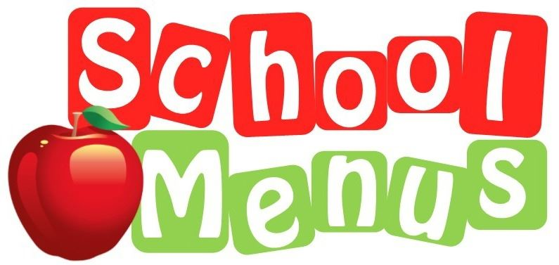

Child’s Name: ______________________ Class: ___________

Allergens - If your child is allergic to one of the 14 main allergens, please ensure you speak to the Main School Office

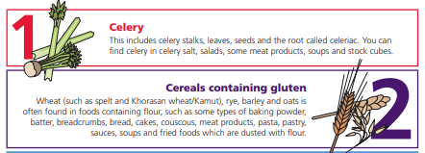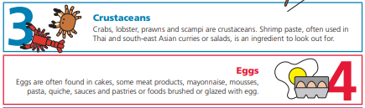
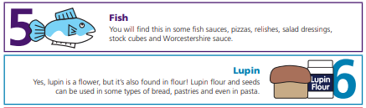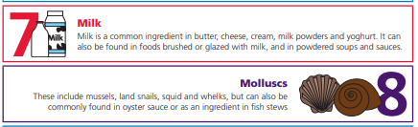
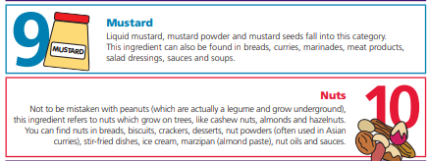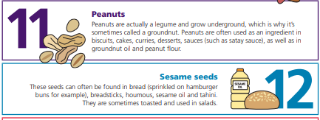

Dietary Requirements
Parents can notify the school office of their child’s dietary requirements, whether religious or medical and these are noted on the system. The Children will wear the appropriate coloured band, all staff members are aware of any dietary requirements to ensure the wrong food item is not given to the child.



