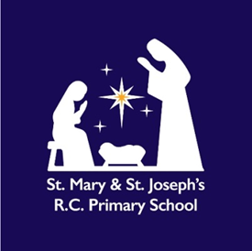
“Being different, Belonging together in the family of God”
St Mary and St Joseph’s RC Primary School
Bennington Street, Blackburn, Lancashire
BB2 3HP

Dear Parents and Carers

Further to our consultation regarding the new statutory curriculum subject, Relationship and Health Education, we are pleased to let you know that our school has decided to adopt the programme, Life to the Full, produced by the Catholic educational organisation, Ten Ten Resources.

The Life to the Full programme is based on the structure of ‘A Model Catholic RSE Curriculum’ by the Catholic Education Service. This model curriculum was highlighted as a work of good practice by the Department of Education so we therefore have confidence that the programme will be fit for purpose in supporting the growth and development of your child.

Life to the Full is much more than a series of lessons. It is an entire platform of creative resources that will engage, inform and inspire our children and, indeed, you as parents. This includes interactive video content, story-based activities, employing a wide range of teaching tools, original worship music and an accompanying programme of classroom prayers.

In addition there will be an online parent platform so that you, as parent and carers, can engage with the teaching and deepen the experience for your child. To access the online parent platform please visit: www.tentenresources.co.uk/parent-portal
School Username: mary-joseph-bb2
School Password: family-22-bb2
Life to the Full is intended to be partnership between home, school and church. We know that you already do a fantastic job and we see our new programme, Life to the Full, as a means to further develop, support and enrich the partnership between home, school and church so that your child is fully supported.
Yours Sincerely
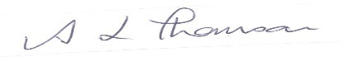
Andrea Thomson

