Design Technology – Whole School Overview
 | Autumn Term |  | Spring Term |  | Summer Term
EYFS | 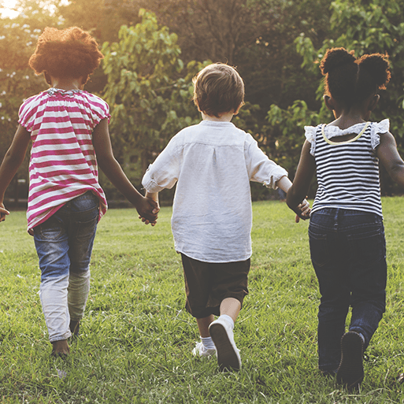  Me and My Community  Emergency Vehicles  Children explore the special features of emergency vehicles and are then supported in making their own vehicles to use in their play. Children learn to talk about their designs and adapt them to make them even better.  Teamwork  Using a range of construction resources eg. cardboard tubes, plastic tubes/ guttering and small plastic balls, the children work together to make a large marble run. | 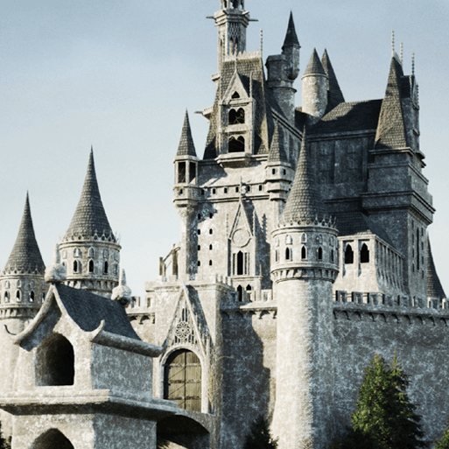  Once Upon A Time  Building Bridges  Children work in teams with a range of construction resources to make a bridge to span two tables or two chairs. Once constructed it is tested to see how many toys it can hold. Children need to work together to decide which materials they will use and how they will attach their bridge to the tables or chairs.  Fantasy Homes  A range of cardboard boxes, tubes, 3-D shapes and decorations are added to the construction area for the children to build castles and fairy tale homes to inspire their creative thinking.  A coach for Cinderella  In this project children are provided with a range of construction kits with wheels and axles for the children to make Cinderella a new form of transport to get to the ball. |   Starry Night  Make a cuddle pet  Children make a cuddle pet/worry doll to look after using a sock and a range of materials eg. wadding, cotton wool or bubble wrap for stuffing, and buttons or googly eyes and felt for features. A cut out heart is put inside and the children invited to make a wish.  Rocket Builders  Children create a spacecraft or props to enhance their space role play, such as jet packs and space helmets using a range of construction equipment.  Moon Buggies  Using a variety of construction kits with wheels and axles children design and make moon buggies and create a rocky landscape using egg boxes and fabric for the moon buggies to travel over. | 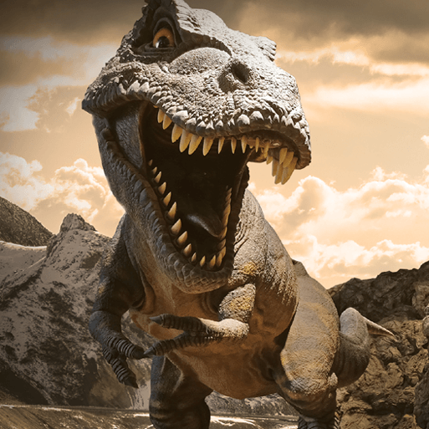  Dangerous Dinosaurs  Frozen in time  Children use a balloon filled with water and containing a small dinosaur or prehistoric animal toy to replicate a dinosaur egg. The balloon is then frozen and the children given the challenge of freeing the animal using water sprays filled with warm water. | 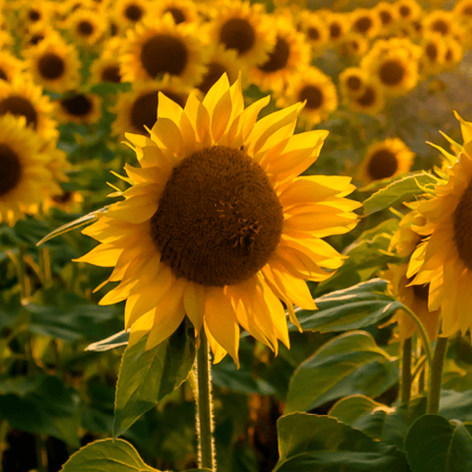  Sunshine & Sunflowers  Flower Art  Children look at various pictures of gardens, such as Bauerngarten by Gustav Klimt, The Flowered Garden by Claude Monet, Murnau The Garden II by Wassily Kandinsky or Flower Garden by Emile Nolde. They are then reminded of Errol who dreamed of a garden in the story Errol's Garden by Gillian Hibbs. The children then paint a dream flower garden using the paintings as inspiration.  Crop Protectors  Children learn about scarecrows and the job they play in protecting seeds/crops.They explore different ways of discouraging birds without harming them. Children go on to make a CD mobile to protect their garden using acrylic gems, silver foil, beads, glass pebbles, sequins  etc.  Summer Tech  Children explore a range of technology used in the summer eg. a handheld fan, disposable camera, wind-up radio, headtorch and eReader. | 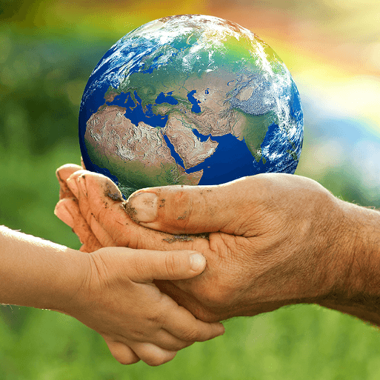  Big Wide World  Animal Masks  In this project the children draw an animal's face that they would like to create as a mask. They talk about the resources and skills they might use to create their mask. When their designs are completed they create their mask using a variety of craft materials. This project introduce skills, such as paper curling and folding for the children to add detail to their masks.  Buildings around the world  Using construction resources children create buildings inspired by pictures of buildings from around the world.
 | 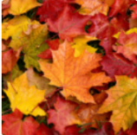  Exploring Autumn  Build it up  Children learn to construct simple structures and models using wooden log slices and branches.  Conker Run  The children work together to make a run for conkers using a variety of cardboard tubes, plastic tubes or guttering. |   Sparkle and Shine  Build it  Children use shiny materials and shiny wrapped wooden blocks to construct simple structures and models. | 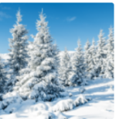  Winter Wonderland  Frozen  In the outside area, children use silicone moulds and natural materials, including leaves, twigs and petals, to make ice decorations. The decorations are then left outside on a cold night to freeze and observed during the day to see what happens. A range of materials, including bubble wrap and silver foil, are used by the children to wrap the ice in to see if this affects the freezing and thawing process.  Snow Mobiles  In this project children use a variety of construction kits to make a vehicle that could travel across the ice and snow.  Ice Building  Children use ice cubes/artificial ice cubes in a Tuff Tub for slippery and melty building fun. The children learn about the properties of ice and are challenged to make a tower with the blocks and see how high they can build. | 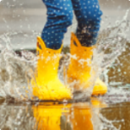  Puddles and Rainbows  Is it waterproof  Children investigate properties of different materials to see if they are waterproof they then work collaboratively to create outside waterproof dens using a den Provide a range of waterproof fabrics, tarpaulins and pegs. |   Shadows and Reflections  Symmetrical Buildings  Children construct simple symmetrical structures and models using wooden blocks, lego blocks and building bricks.  Mirrored Building  Children create a building from Lego or other construction blocks in a Tuff Tub lined with mirrored card they then use a camera or tablet to take photographs of their buildings and their reflections. | 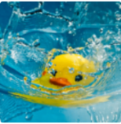  Splash!  Boats  In this project the children are challenged to create boats using construction kits and small world people. The children can then sail their boats.  Races  Children have a selection of various wind up water toys in a water tray for them to explore and race.
Year 1 | 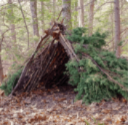  Shade and Shelter  This project teaches children about the purpose of shelters and their materials. It looks at why humans and animals need shade and shelter for warmth and protection from the weather. They investigate, name and describe shelters and design and make shelter prototypes. Children then design and build a play den as a group and evaluate their completed product. |  |   Taxi!  This project teaches children about wheels, axles and chassis and how they work together to make a vehicle move. The children explore the form and function of a London taxi. They then go on to design and make a model of a London taxi which can move and has either fixed or moving axles. |  | 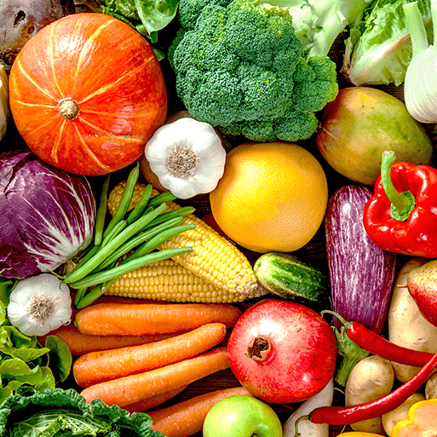  Chop, Slice and Mash!  This project teaches children about sources of food and the preparatory skills of peeling, tearing, slicing, chopping, mashing and grating. They use this knowledge and techniques to design and make a supermarket sandwich according to specific design criteria.
Year 2 | 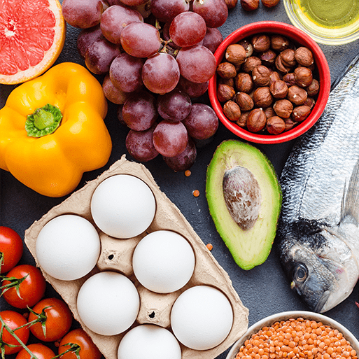  Remarkable Recipes  This project teaches children about sources of food and tools used for food preparation. They also discover why some foods are cooked and learn to read a simple recipe. The children choose and make a new school meal that fulfils specific design criteria. |  | 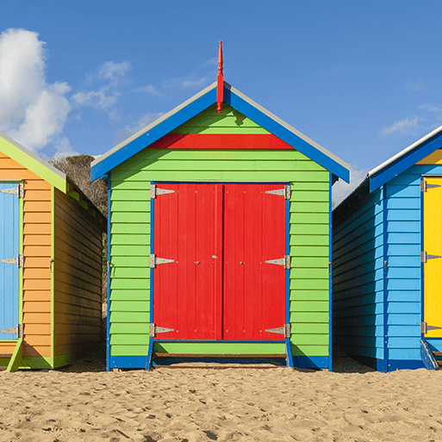  Beach Hut  In this project learn about beach huts, what they look like and what they are used for. They design a 3D beach hut with the following in mind; ‘How big will your beach hut be? How will you make your design strong? How will you decorate your beach hut? How will you make the roof?’  This project teaches children about making and strengthening structures, including different ways of joining materials. |  | 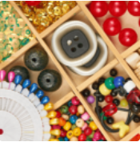  Cut, Stitch and Join  This project teaches children about fabric home products and the significant British brand Cath Kidston. They learn about sewing patterns and using a running stitch and embellishments before making a sewn bag tag. | 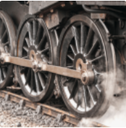  Push and Pull  This project teaches children about three types of mechanism: sliders, levers and linkages. They make models of each mechanism before designing and making a greetings card with a moving part.
Year 3 | 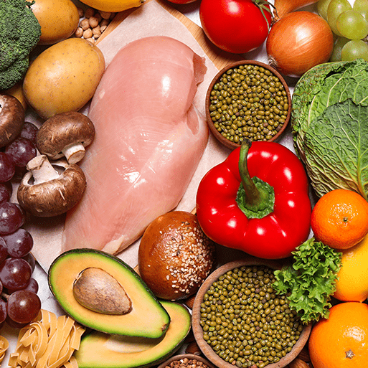  Cook Well, Eat Well  This project teaches children about food groups and the Eatwell guide. They learn about methods of cooking and explore these by cooking potatoes and ratatouille. The children choose and make a taco filling according to specific design criteria. |  | 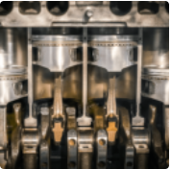  Making it Move  The children first recap the terms ‘machine’ and ‘mechanism’ from previous learning and revisit the names of different mechanisms, including sliders, levers, linkages, axles and wheels. The children investigate different examples of machines and learn what work each machine does, the movement they create and their benefits. This project then introduces the children to cam mechanisms. They experiment with different shaped cams before designing, making and evaluating a child's automaton toy. |  | 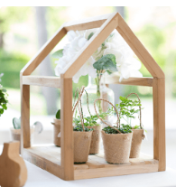  Greenhouse  This project teaches children about the purpose, structure and design features of greenhouses, and compares the work of two significant greenhouse designers. They learn techniques to strengthen structures and use tools safely. They use their learning to design and construct a mini greenhouse.
Year 4 | 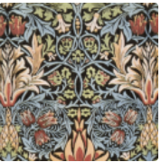  Functional Fabrics  This project teaches children about home furnishings and the significant designer William Morris. They learn techniques for decorating fabric, including block printing, hemming and embroidery and use them to design and make a fabric sample. |  | 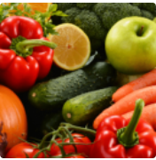  Fresh Food, Good Food  This project teaches children about food decay and preservation. They explore what causes food to decay; how microorganisms get onto food; who invented pasteurisation and how pasteurisation keeps food fresh for longer. They also learn why the ‘use by’ date was invented. They discover key inventions in food preservation and packaging, then make examples. The children prepare, package and evaluate a healthy snack. |  | 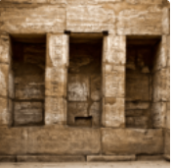  Tomb Buildrers  This project teaches children about simple machines, including wheels, axles, inclined planes, pulleys and levers, exploring how they helped ancient builders to lift and move heavy loads.
Year 5 | 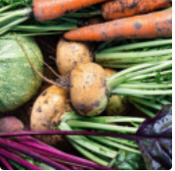  Seasonal Eating  This project teaches children about the meaning and benefits of seasonal eating, including food preparation and cooking techniques.  The children recap how fruit and vegetables provide people with the essential nutrients, such as vitamins, minerals and fibre, that our bodies need to stay healthy. |  | 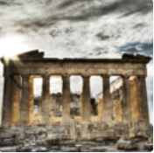  Architecture  This project teaches children about how architectural style and technology has developed over time and then use this knowledge to design a building with specific features. |  | 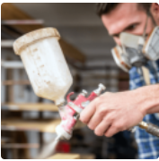  Moving Mechanisms  This project teaches children about pneumatic systems. They experiment with pneumatics before designing, making and evaluating a pneumatic machine that performs a useful function.
Year 6 | 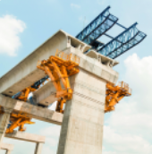  Engineer  This project teaches children about remarkable engineers and significant bridges, learning to identify features, such as beams, arches and trusses. They complete a bridge-building engineering challenge to create a bridge prototype. |  | 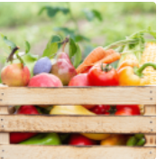  Food For Life  The children first begin with a recap on the importance of a healthy lifestyle and the role of a healthy, balanced diet.This project teaches children about processed food and healthy food choices. They make bread and pasta sauces and learn about the benefits of whole foods. They plan and make meals as part of a healthy daily menu, and evaluate their completed products. |  | 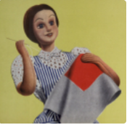  Make, Do and Mend  In this project the children to explore what the Make Do and Mend campaign was and how it influenced family life, fashion and the war effort in general. The children use their findings to create a digital scrap page on the theme, inserting text and images. As part of this project the children learn a range of simple sewing stitches, including ways of recycling and repurposing old clothes and materials.

