**Class Dojo – Using portfolio for ASL**

* All children will have been assigned an additional log in to access their portfolio at home
* Click on the portfolio tab to reach this page

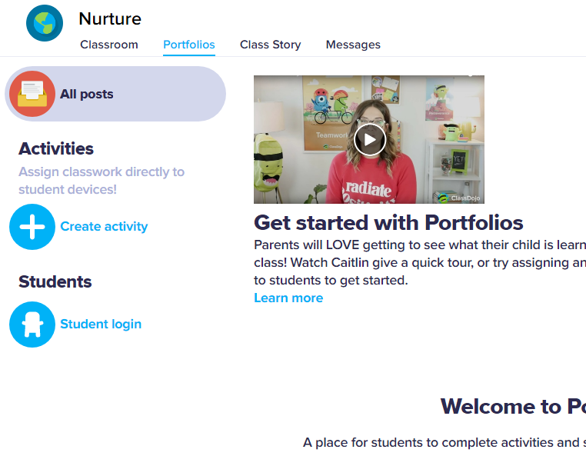

* Click on 
* Your screen will then give you the following options
* 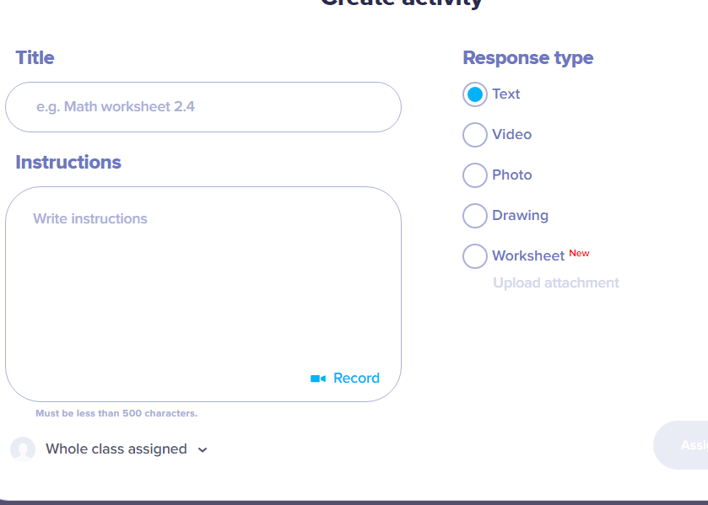

Can assign to individuals

Make this really specific with dates – activity number etc to support you in identifying

Use this to send a video – this could also be a modelling session

This section allows you to choose how you want the children to complete the work

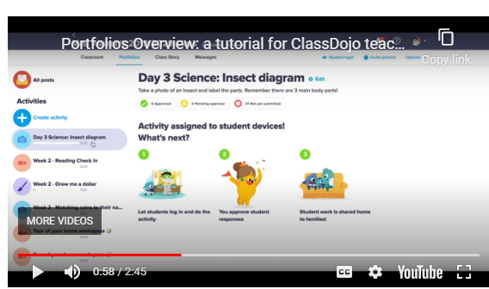

Your activities set will appear in this column

To edit the lesson or delete use the cog icon

* To view work completed click on 
* 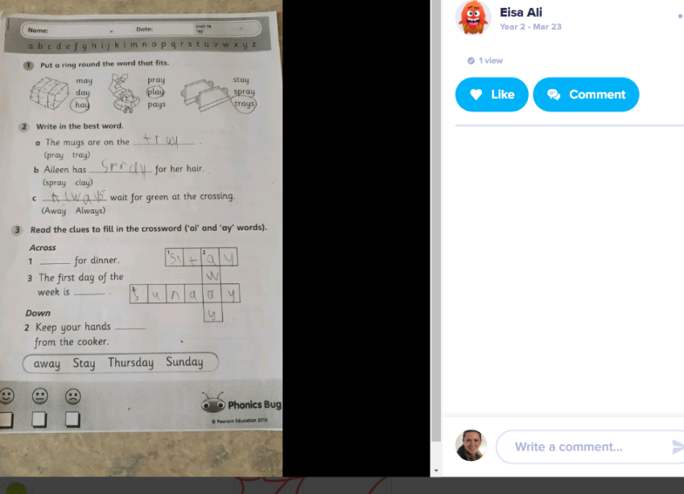To view a child’s work click on it to bring up this tab
* This is the view from the pupils screen

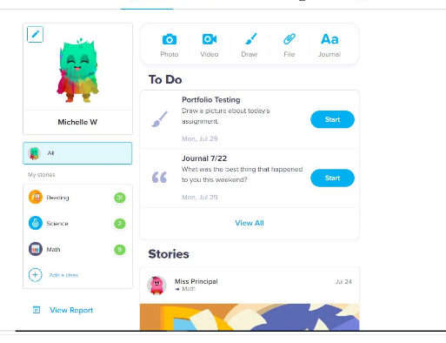

* WORD documents are not accepted on some formats so please convert these before posting.